Autonomous Payload Delivery Challenge
Design Report
Design team:
Neil Abadejos
Bernen Alba
William Dorrance
Scott Lewis
Hugo Mayoral
Mark Novilla
Sponsored by: San Diego State University

Department of Electrical and Computer Engineering

Submitted on: May 16, 2014

Table of Contents

Abstract ………………………………………………………………………………………………………………………………..2

Introduction ………………………………………………………………………………………………………………………….3

Design Goals …………………………………………………………………………………………………………………………3

System Overviews ……………………………………………………………………………..……………..………………….7

Driving and Steering System ……………………………………………………………………………..………..7
Navigation ……………………………………………………………………………..……………..……………..……8
Obstacle Avoidance ……………………………………………………………………………..……………..……10
Beacon Detection ……………………………………………………………………………..……………..………13
Payload System ……………………………………………………………………………..……………..…………14

PCB Layout ……………………………………………………………………………..……………..……………..……………17

Vehicle Design ……………………………………………………………………………..……………..……………..………19

Conclusion ……………….………………………..……………..……………..…………………………………………………20

References ……………………………………………………………………………..……………..……………..……………22

Appendices ……………………………………………………………………………..……………..……………..……………23

PCB Layouts ……………..……………..……………..……………..……………..……………..……………..….24

Budget ……………..……………..……………..……………..……………..……………..……………..………….25

Milestones ……………..……………..……………..……………..……………..……………..……………..……26

Abstract

Alternative Innovations needed to design and build a fully autonomous vehicle to compete in the Autonomous Payload Delivery Challenge. A team was formed with the goal of producing an autonomous vehicle that could guide itself to three target locations and deliver a small payload to each location. After thorough researching and testing of several components, our team integrated several key components to satisfy our team’s focus on speed and course vision. The testing and results showed that our innovative vehicle would utilize our team’s focuses to compete and be victorious on the day of the competition.

Introduction
American soldiers risk their lives every day while on duty. One of the major concerns is the amount of deaths caused by improvised explosive devices. In 2013, according to USA TODAY, “60% of casualties are IED related”. With that in mind, it is imperative to significantly decrease this statistic. IEDs can be created by anyone with just a few easily accessible items, which in turn could harm innocent lives. IEDs are bombs fabricated in an improvised manner, which are comprised of destructive or lethal materials. An IED consists of a switch, a fuse, a container, an explosive component, and a power source. Due to the diverse ways an IED can be fabricated, which may be difficult to locate and disarm. The most common method of disarming IEDs is to drop a small explosive nearby the threat to detonate the explosive. Our team has been selected to compete in the Autonomous Payload Delivery Challenge, which will simulate this disarming routine. Our project includes the simulation of an autonomous vehicle that can guide itself to three target locations of suspected IEDs, drop a small payload within each location’s vicinity, and then finally return to its starting location. This competition simulates a tangible and substantial dilemma that affect hundreds of lives and we here at Alternative Innovations has designed and produced a viable solution in our team’s robot LILRO, short for Let it Load, Rover.

Design Goals
For the Autonomous Payload Delivery Competition, our team had to design and build a fully autonomous vehicle that is capable of navigating itself through a course and deliver a payload to each target location. Once our team was selected to compete in this competition, we had several important decisions to make that would dictate our vehicle’s design and functionality. After making several key decisions, our team was able to produce an intelligent and innovative vehicle that was able to complete the course in a precise and timely manner.
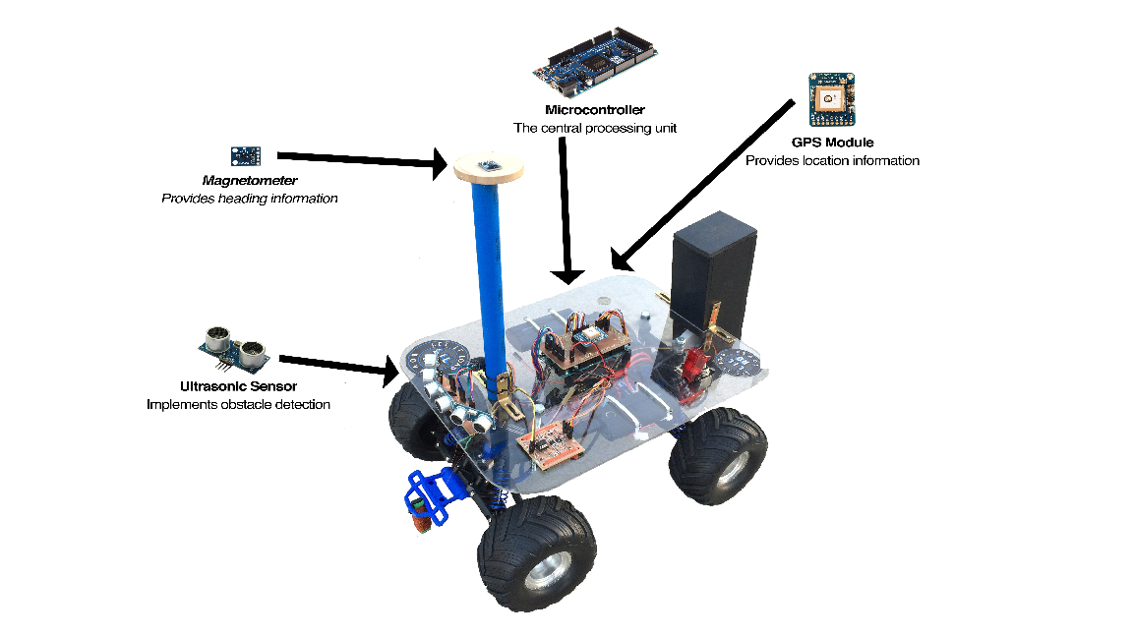

Figure 1: LILRO’s key components and system overview.
The first main design decision our team had to make was to select which chassis we wanted to utilize. The two apparent choices were between two drive systems; a Radio Controlled car or a Differential Drive robot. Our team spent several days researching the pros and cons of each system’s drive, but in the end, our team knew that we wanted to primarily focus our vehicle’s design around speed. Accordingly, we decided to go with an RC car, Traxxas Monster Jam, for our vehicle’s chassis. With this decision, we knew that our vehicle would not be capable of traveling in straight lines or making quick turns. But we would have an edge in terms of higher top speeds and because of the brand of RC car we chose, we were offered a plethora of easily obtainable aftermarket parts.
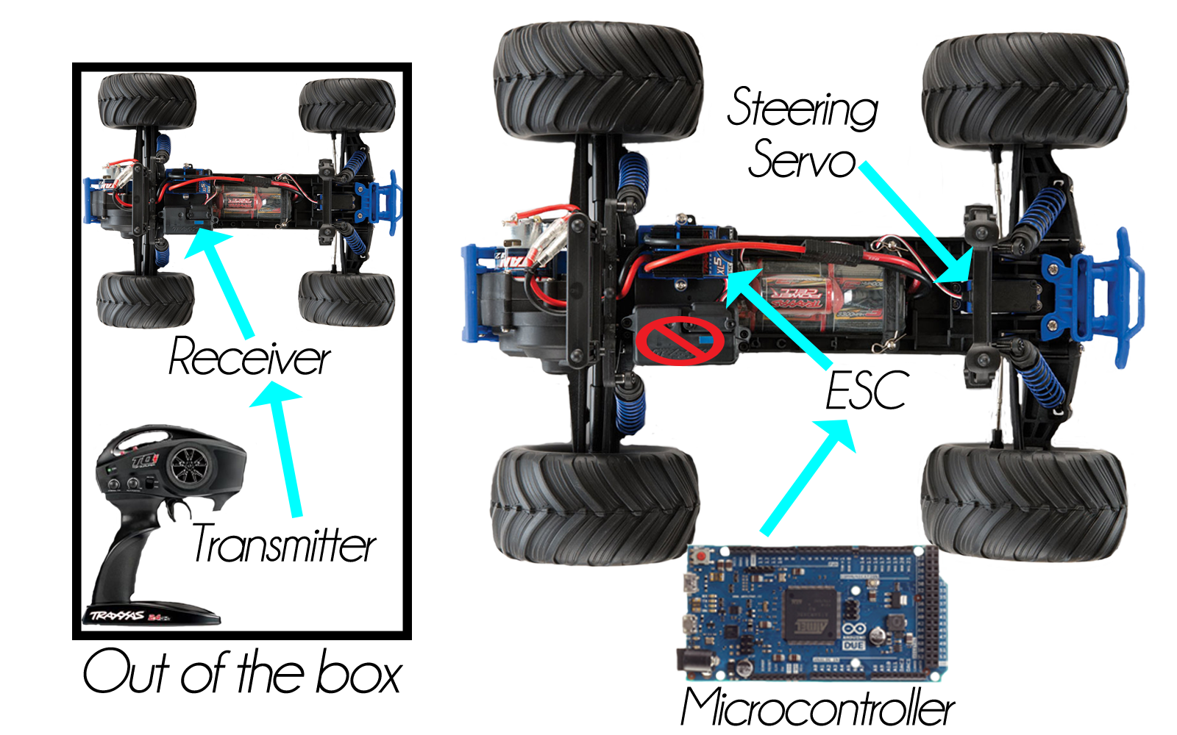

Figure 2: Radio Controlled versus Autonomous.
Once our team decided on the appropriate chassis, we needed the components to make our vehicle autonomous and functional. We needed the central “brain” to control our vehicle and make several essential calculations. The microcontroller our team decided utilize was the Arm Cortex-M3, which was more than capable of handling all of the processing as well as provided a sufficient amount of necessary input and output pins. The microcontroller would provide the proper output signals and calculations to make our vehicle functional and autonomous.
As for our navigation system, our team realized that we would need two vital components to guide our robot to the target locations. One critical component is a GPS module, providing us with location information in longitudes and latitudes. The other essential component being a magnetometer to provide our vehicle’s current heading information. Our team wanted a low-powered and highly sensitive GPS module that could provide the necessary data at the speeds our robot would be traveling. We decided to go with the Adafruit Ultimate GPS Breakout with 66 channels and up to a 10 hertz update rate. Alternatively, we needed a magnetometer with a high resolution and a comparable output update rate to act as our vehicle’s onboard digital compass. For these reasons, our team decided to utilize the HMC5883L , which could provide our microcontroller with simple, yet reliable heading information. With both of these modules working together simultaneously, LILRO is capable of autonomously guiding itself to the target locations.
With the components of the navigation system chosen, our team had to evaluate LILRO’s mechanism for dealing with obstacles on its way to the target locations. With our main essential focus on speed, our team decided to focus on another essential; course vision. Because of the size of the course, we wanted to have a substantial amount of vision to properly avoid any obstacles. After comparing several types of sensors, our team decided to utilize ultrasonic sensors for LILRO’s obstacle detection and avoidance system. We went with the HC-SR04 Ultrasonic Range Finder, as it was low cost and provided the fitting amount of range for the speeds our vehicle would be traveling at. Alternative Innovations spent a great deal of time researching and testing all of the key components to satisfy our team needs and make our vehicle competition ready.

Driving and Steering System
After connecting the receiver module to an oscilloscope we were able to determine both the steering and the speed controller were controlled through pulse width modulation. The peak times ranged from 1-2 milliseconds with a 10ms refresh rate. For the steering, 1 millisecond would represent a full left turn, 1.5ms would be straight, and 2ms would be full right with different degrees of turns for every value in between. For the speed, it was a very similar signal except; 1.5ms was neutral, 1ms was full reverse, and 2ms was full speed forward. Using the Arduino’s servo library we were able to replicate those signals through very little altering to the library’s header file. Typically servos have a refresh rate of 20ms, but we had to modify the 20ms to a 10ms refresh rate to allow the ESC to function properly.
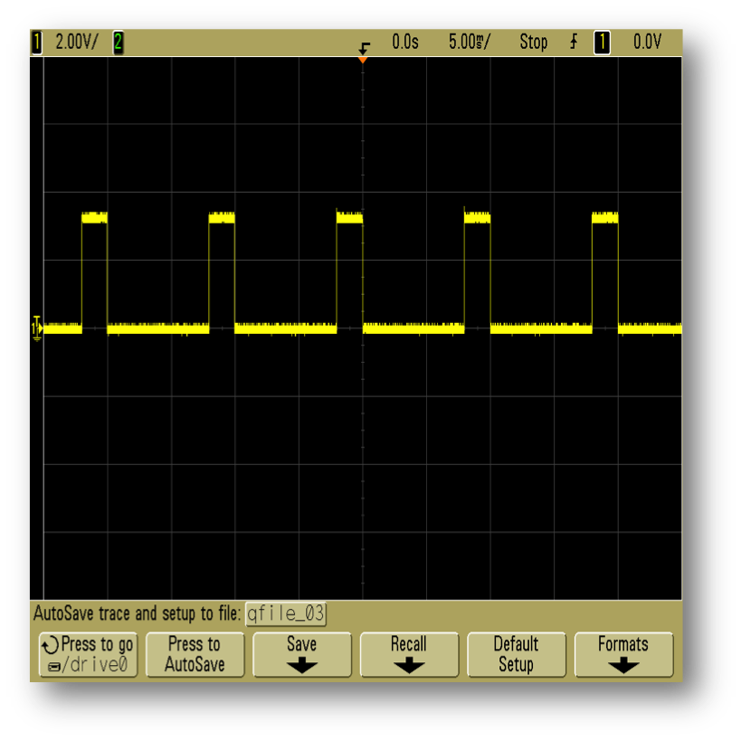
Figure 3: Oscilloscope output Pulse Width Modulation to control the driving and steering.
Fortunately, the steering would still behave properly when refreshed twice the usual rate. The microcontroller allowed for two ways to describe the PWM peak time and that was either through angle format (0-180 degrees), or in the exact milliseconds desired for the peak time. Once programmed, the microcontroller would continually output those signals via a digital output pin.

Navigation
Our team’s navigation system is comprised of a GPS module and a magnetometer. The GPS module provides location information while the magnetometer provides our vehicle’s current heading. LILRO’s navigation algorithm is based on simple triangulation and distance calculations. Our GPS module, the Adafruit Ultimate GPS Breakout, was set to a baud rate of 115200 and an update rate of 2Hz, which would provide our microcontroller with the necessary information in a timely fashion with a given accuracy of around 3 meters. This particular GPS module gave us an accuracy of approximately six to nine feet of the actual GPS location. And with this GPS, we were able to disable the outputted National Marine Electronics Association (NMEA) sentences to the minimum amount of data to only output the fundamental sentence which was the Global Positioning System Fix Data ($GPGGA). We would pull data sentence by sentence only parsing this specific sentence ending with a new line to consume less processing power.
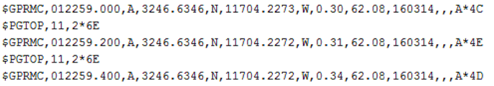

Figure 4: NMEA GPS location information.
First, we initialized the target locations GPS locations in our navigation code. Next, since we know the vehicle’s current location and the location of each of the beacons, we were able to determine the distance between by providing the GPS coordinates and utilizing the distance formula between the two points. Therefore, by finding the distance between the current location and the target location, or the hypotenuse of a triangle, our team was also able to calculate the correct heading necessary to arrive at the target location by having the microcontroller calculate the arctangent of the difference in the two location’s latitudes over the difference in longitudes.
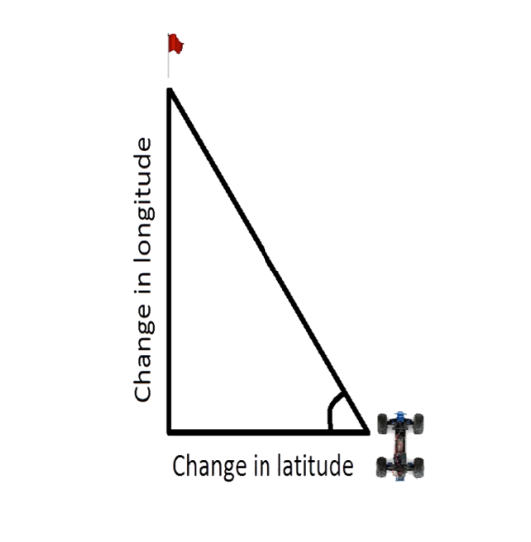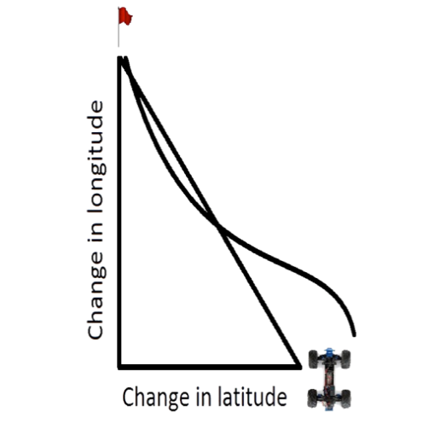

Figure 5: Navigation; triangulation to target diagram.
Once the microcontroller calculates the required heading to arrive at the target location’s GPS coordinates, we then utilize the magnetometer to provide the vehicle’s current heading. The magnetometer we utilized was the HMC5883L, which provided a resolution of up to 5 milligauss and a calibrated heading accuracy of 1° to 2°. Knowing the required heading and LILRO’s current heading, the microcontroller subtracts the current heading with the required heading to determine the amount. The amount of error will dictate which direction our car would turn towards, utilizing our team’s steering and driving system.
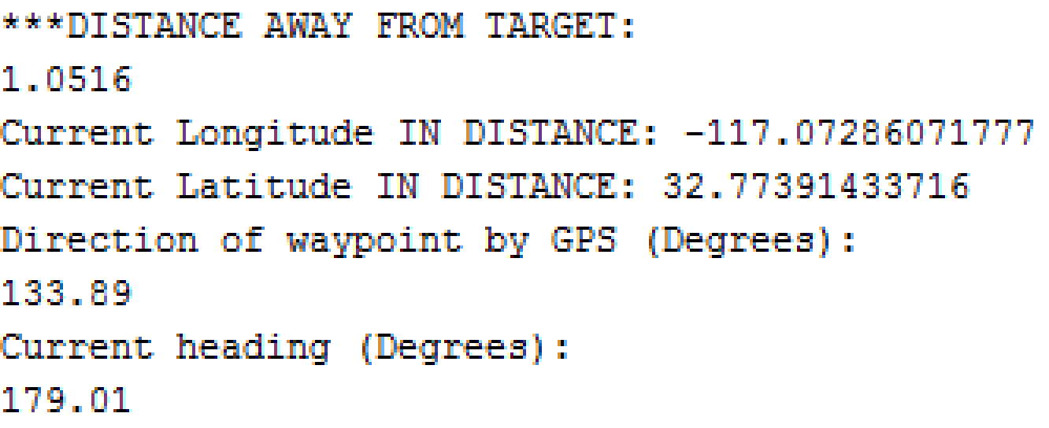

Figure 6: GPS coordinates, magnetometer’s current heading and required heading.

Obstacle Avoidance
Due to the high speeds that the vehicle would be traveling, we required an obstacle detection system that would consist of a very wide field of vision to be capable of responding accordingly when it nears an obstacle. The system was comprised of three HC-SR04 Ultrasonic Sensors in order to provide the detection span we were looking for. Having three sensors would also bring several advantages such as having a more accurate depiction of where the object is located and reducing the turn radius when an object is detected. Reducing the turn radius would allow the vehicle to avoid straying too far from the current heading while maintaining a higher speed.
Once an obstacle was detected, the vehicle was programed to react to the distance and location of an obstacle. If an obstacle was to be found on the right, it would slightly move left, vice versa. If an obstacle is found between two sensors, the vehicle will turn to the opposite location according to the distance to avoid straying from the heading. The algorithm contained different turn radii determined by the distance in which an object is detected as seen in the Appendix.
Through testing and data sheet analysis, we found that the HC-SR04 Ultrasonic Sensors would be the most optimal sensors to use for our system. We knew we would be working with a 5V device on a 3.3V microcontroller but we would only have a 15mA current pull for each ping. To reach the 5V requirement we would use an external power source to supply the required voltage. We also found that each sensor would trigger eight 40Hz waves per ping, which meant we would have an accurate echo response. To prevent cross sensor detection, the sensors were programed to ping within 33ms from each other. This gave each sensor plenty of time to respond to a ping or respond if no ping was retrieved.
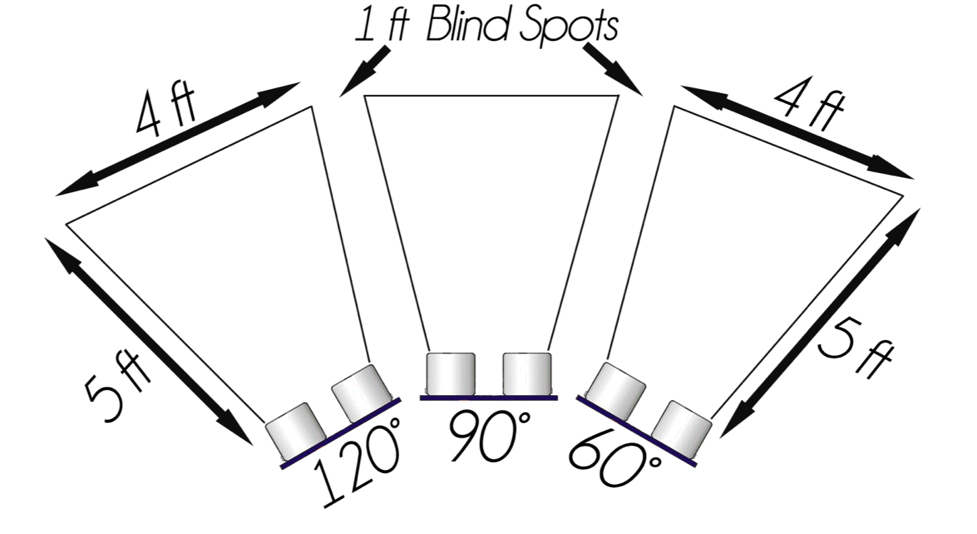
Figure 7: Obstacle Avoidance System Overview.
Once the sensors were programed to send and receive a signal, the formula used to find the distance was $Distance=(Trigger HIGH time ×Velocity of Sound)/2$ where the Trigger High Time was set to 10ms, the Velocity of Sound was rounded to 340m/s. Once this was complete, we translated the time from microseconds to inches and centimeters to check if the distances found were correct. When making measurements, our most accurate detections were made from 2cm to 1.5/1.8 meters with a +/- 5cm accuracy. At 1.524m, or five feet, each sensor had a measuring angle of 15 degrees, which allowed a detection width of four feet at that distance. The sensors were strategically placed within 30 degrees from the center sensor to increase the field of vision and help prevent any cross sensor detection. Our system’s total detection field was of 14 feet with only two one-foot blind spots between each sensor.
At the time it was certain that each sensor’s measurements were accurate, we began to implement the turning algorithm on one sensor. We gave different conditions to a single sensor by distance.

3 to 26 inches | 0
26 to 52 inches | 90
52 to 80 inches | 180

Figure 8: Ultrasonic Sensor ranges
Once the servo responded nicely to the distances, the turning algorithm was applied to 2 sensors then to three. The resulting conditions and servo turn radii-to-distance were (where 90 is driving straight): see Appendix
When the algorithm was complete, an obstacle detection function was placed in the main loop of the program. When the function was called, the microcontroller would have one second to allow the 244ms process to occur.

Beacon Detection
One main requirement of the robotic challenge is the ability to detect an 80kHz, 100mA RMS signal emitting from each beacon. Due to the closed loop nature of each beacon, it produces varying magnetic flux $Ψ$ to a corresponding antenna tuned to the same frequency that produces a varying voltage V_{emf}. This induced voltage can effectively be processed via circuitry with the output fed directly into the microcontroller to detect the strength of the beacon’s emitted signal.
Based on Ampere’s law, the net enclosed current I_{enc} is the same as the line integral of the magnetic field intensity H around a closed path. As well, the magnetic flux density B is related to the magnetic field intensity multiplied by the permeability of free space $μ_{o}$. Taking the integral of the magnetic flux density equates to the magnetic flux $Ψ$through any surface. Thus, any negative change of magnetic flux with respect to time induces varying voltages, V_{emf}.

$$I_{enc}= \oint{H} ⋅dl$$
$$B= μ_{o}H$$
$$Ψ = \int{B} ⋅dS$$
$$V_{emf}= \oint{E} ⋅dl= \int{\frac{dB}{dt}} ⋅dS= -\frac{dΨ}{dt}$$
For our case, the enclosed current of 100mA RMS produces a fixed magnetic flux density, and effectively a non-varying magnetic flux through the surface of the beacon. However, creating an antenna tuned to the same frequency of 80kHz can effectively detect the beacon’s varying magnetic flux with respect to distance that will produce different voltages at different distances away from the signal.
The design of LILRO’s beacon detection system is comprised of four circuitry blocks that drive a GPIO port of the microcontroller. Figures 1 and 2, shown below, feature the circuitry blocks in block and circuit diagram, respectively.
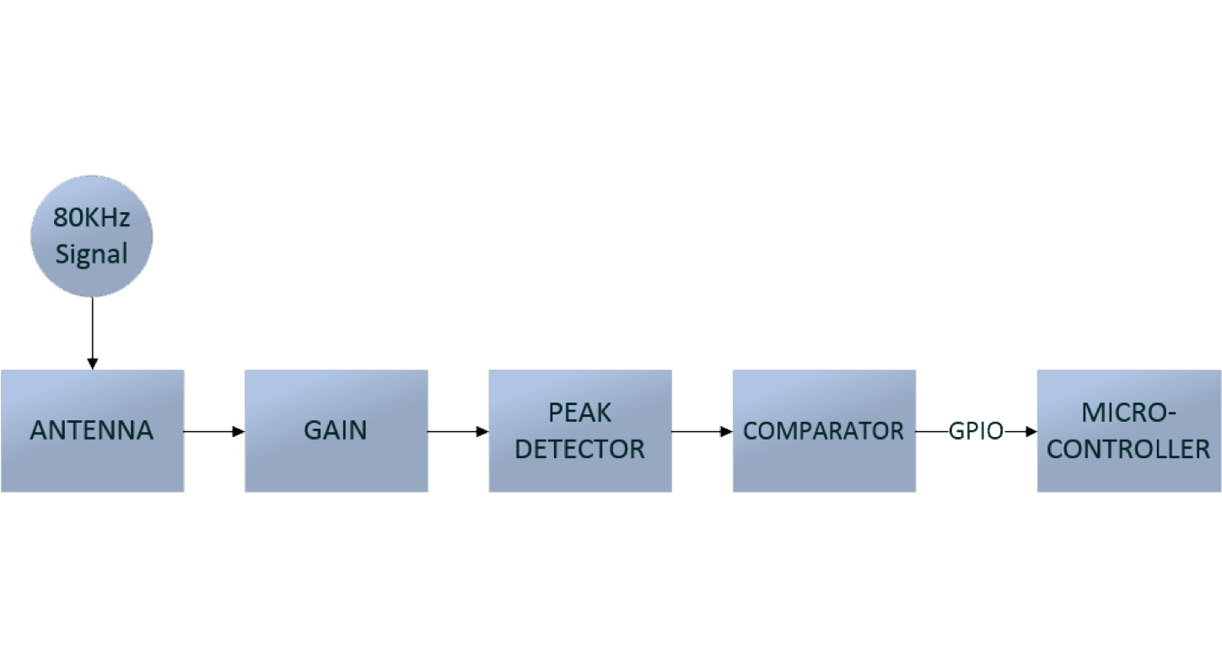
Figure 9: Peak Detection System Block Diagram

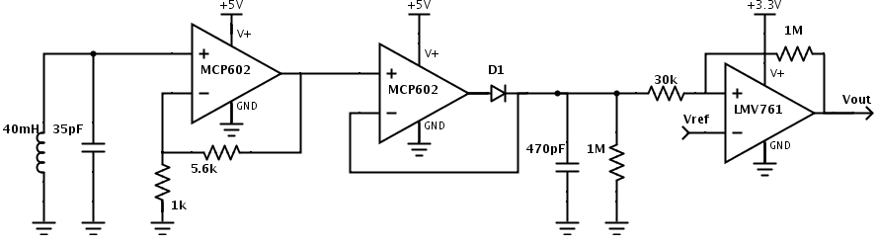
Figure 10: Peak Detection System Circuit Diagram

The antenna is comprised of an LC tank. The inductor is a ferrite rod wrapped with 29AWG magnet wire with 900 turns that equates to 40mH of inductance. To tune the inductor to 80kHz, a 35pF capacitor in parallel was needed. However, the LC tank was down tuned in order to provide only 50V maximum of induced voltage rather than the 150V possible with the LC tank precisely tuned. This was an effort to reduce possible voltage swing issues while using single supply circuitry.
To utilize the voltage being induced by the LC tank, the gain stage incorporates a voltage amplifier. The high input impedance allows the detected signal to be fully processed. It features a non-inverting topology providing a gain of approximately 7. This increases the range of our LC tank from 1ft. to 5ft, effectively. The gain was set to minimize voltage clipping over the antenna’s detectable range.
The peak detector was incorporated in order to hold the peak value of the 80kHz sinusoidal signal. It reduces the amount of sampling the microcontroller would need to process per cycle. The peak detector features a precision diode configuration with a capacitor to hold the peak amplitude, and a resistor in parallel to control the discharge of the capacitor. The capacitor and resistor combination featured a RC time constant $τ$ of 470$μS$ to provide adequate performance, as the period $Τ$ between each peak was 13$μS$.
To maximize processing power for the navigation and obstacle avoidance, a comparator was used to provide detection at set thresholds. Doing so would provide a 3.3V, or logic 1, if the signal crosses the 4ft. voltage amplitude, and provide a 0V, or logic 0, if the signal does not pass the threshold. Hysteresis was added to minimize the effects of noise, as well as the false outputs generated by the equal amplitudes of the sinusoidal signal at various outputs. Effectively the detecting threshold was set to 4ft, however can get as close as 5in of the beacon by counting the amount of time the logic level 1 was held.

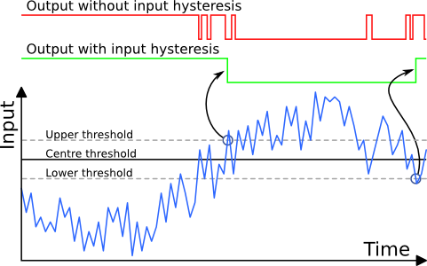
Figure 11: Comparator with and without Hysteresis [2]

Payload System
The payload delivery system was designed to be as simple as possible. This system consists of a chamber, which would hold the payload charges, and a disc that rotates by the use of a servo. The chamber was designed with dimensions of 2.5” x 3” x 9”. The disc had dimensions of 2.5” x 0.5”. The disc was circular-shaped with a 90° cutout on the upper left corner. The disc was then mounted to a servo, which was mounted to the chamber. With all the pieces in place, the payload charges were able to sit inside the system. The first charge would sit inside the cutout of disc. When the system activated, the servo would rotate the disc 180°, dropping the charge sitting inside of the cutout of the disc. While this occurred, the remaining charges are retained in place by the disc.
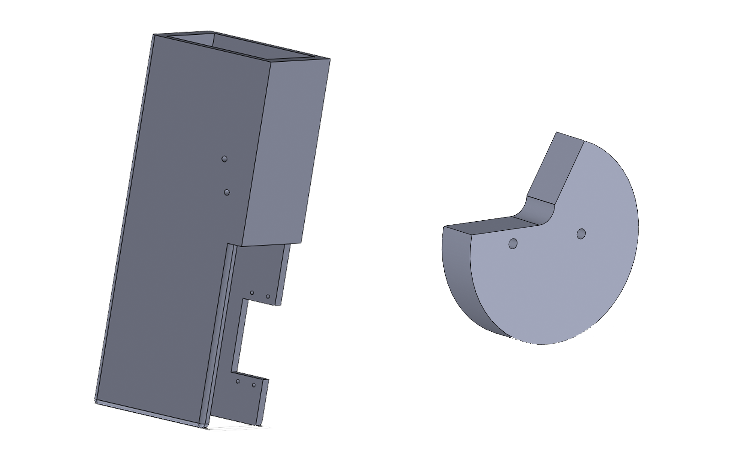

Figure 12: Payload System CAD Overview.

The payload delivery system was originally designed to a 3D printed part, but due to costs restraints the system was made using wood. As a compromise, the revolving disc was printed.

PCB Layout
For the PCB layout, we manufactured three printed circuit boards for our components. We created a microcontroller shield, an antenna board, and an ultrasonic board using Mentor Graphics. We have designed the microcontroller board to facilitate a simplistic wiring design and to allow for easy debugging. The ultrasonic board utilized the placement of three ultrasonic sensors angled to create a 90-degree cone with a detection distance of five feet.
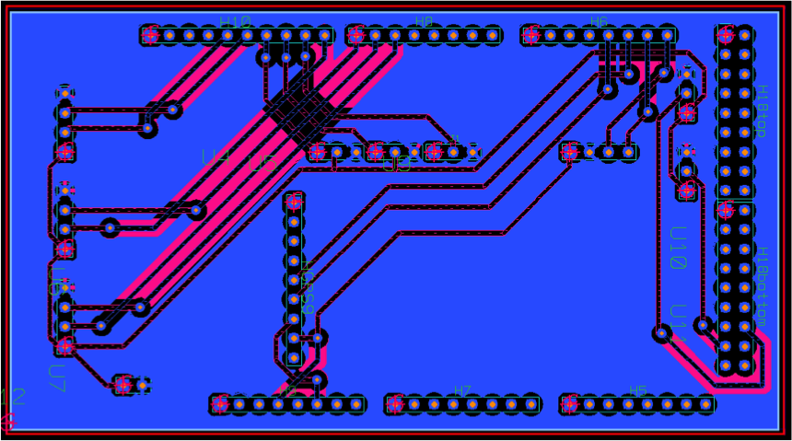

Figure 13: PCB schematic for the microcontroller.
The only revision for PCBs was the ultrasonic sensor board, due to the placement of the pins relative to the orientation of the sensor. In short, the sensor’s pins were accidentally placed backwards due to the simplicity of the design of the board. An easy fix allowed a second revision and produced results. The microcontroller and antenna PCB worked as designed with no revisions.
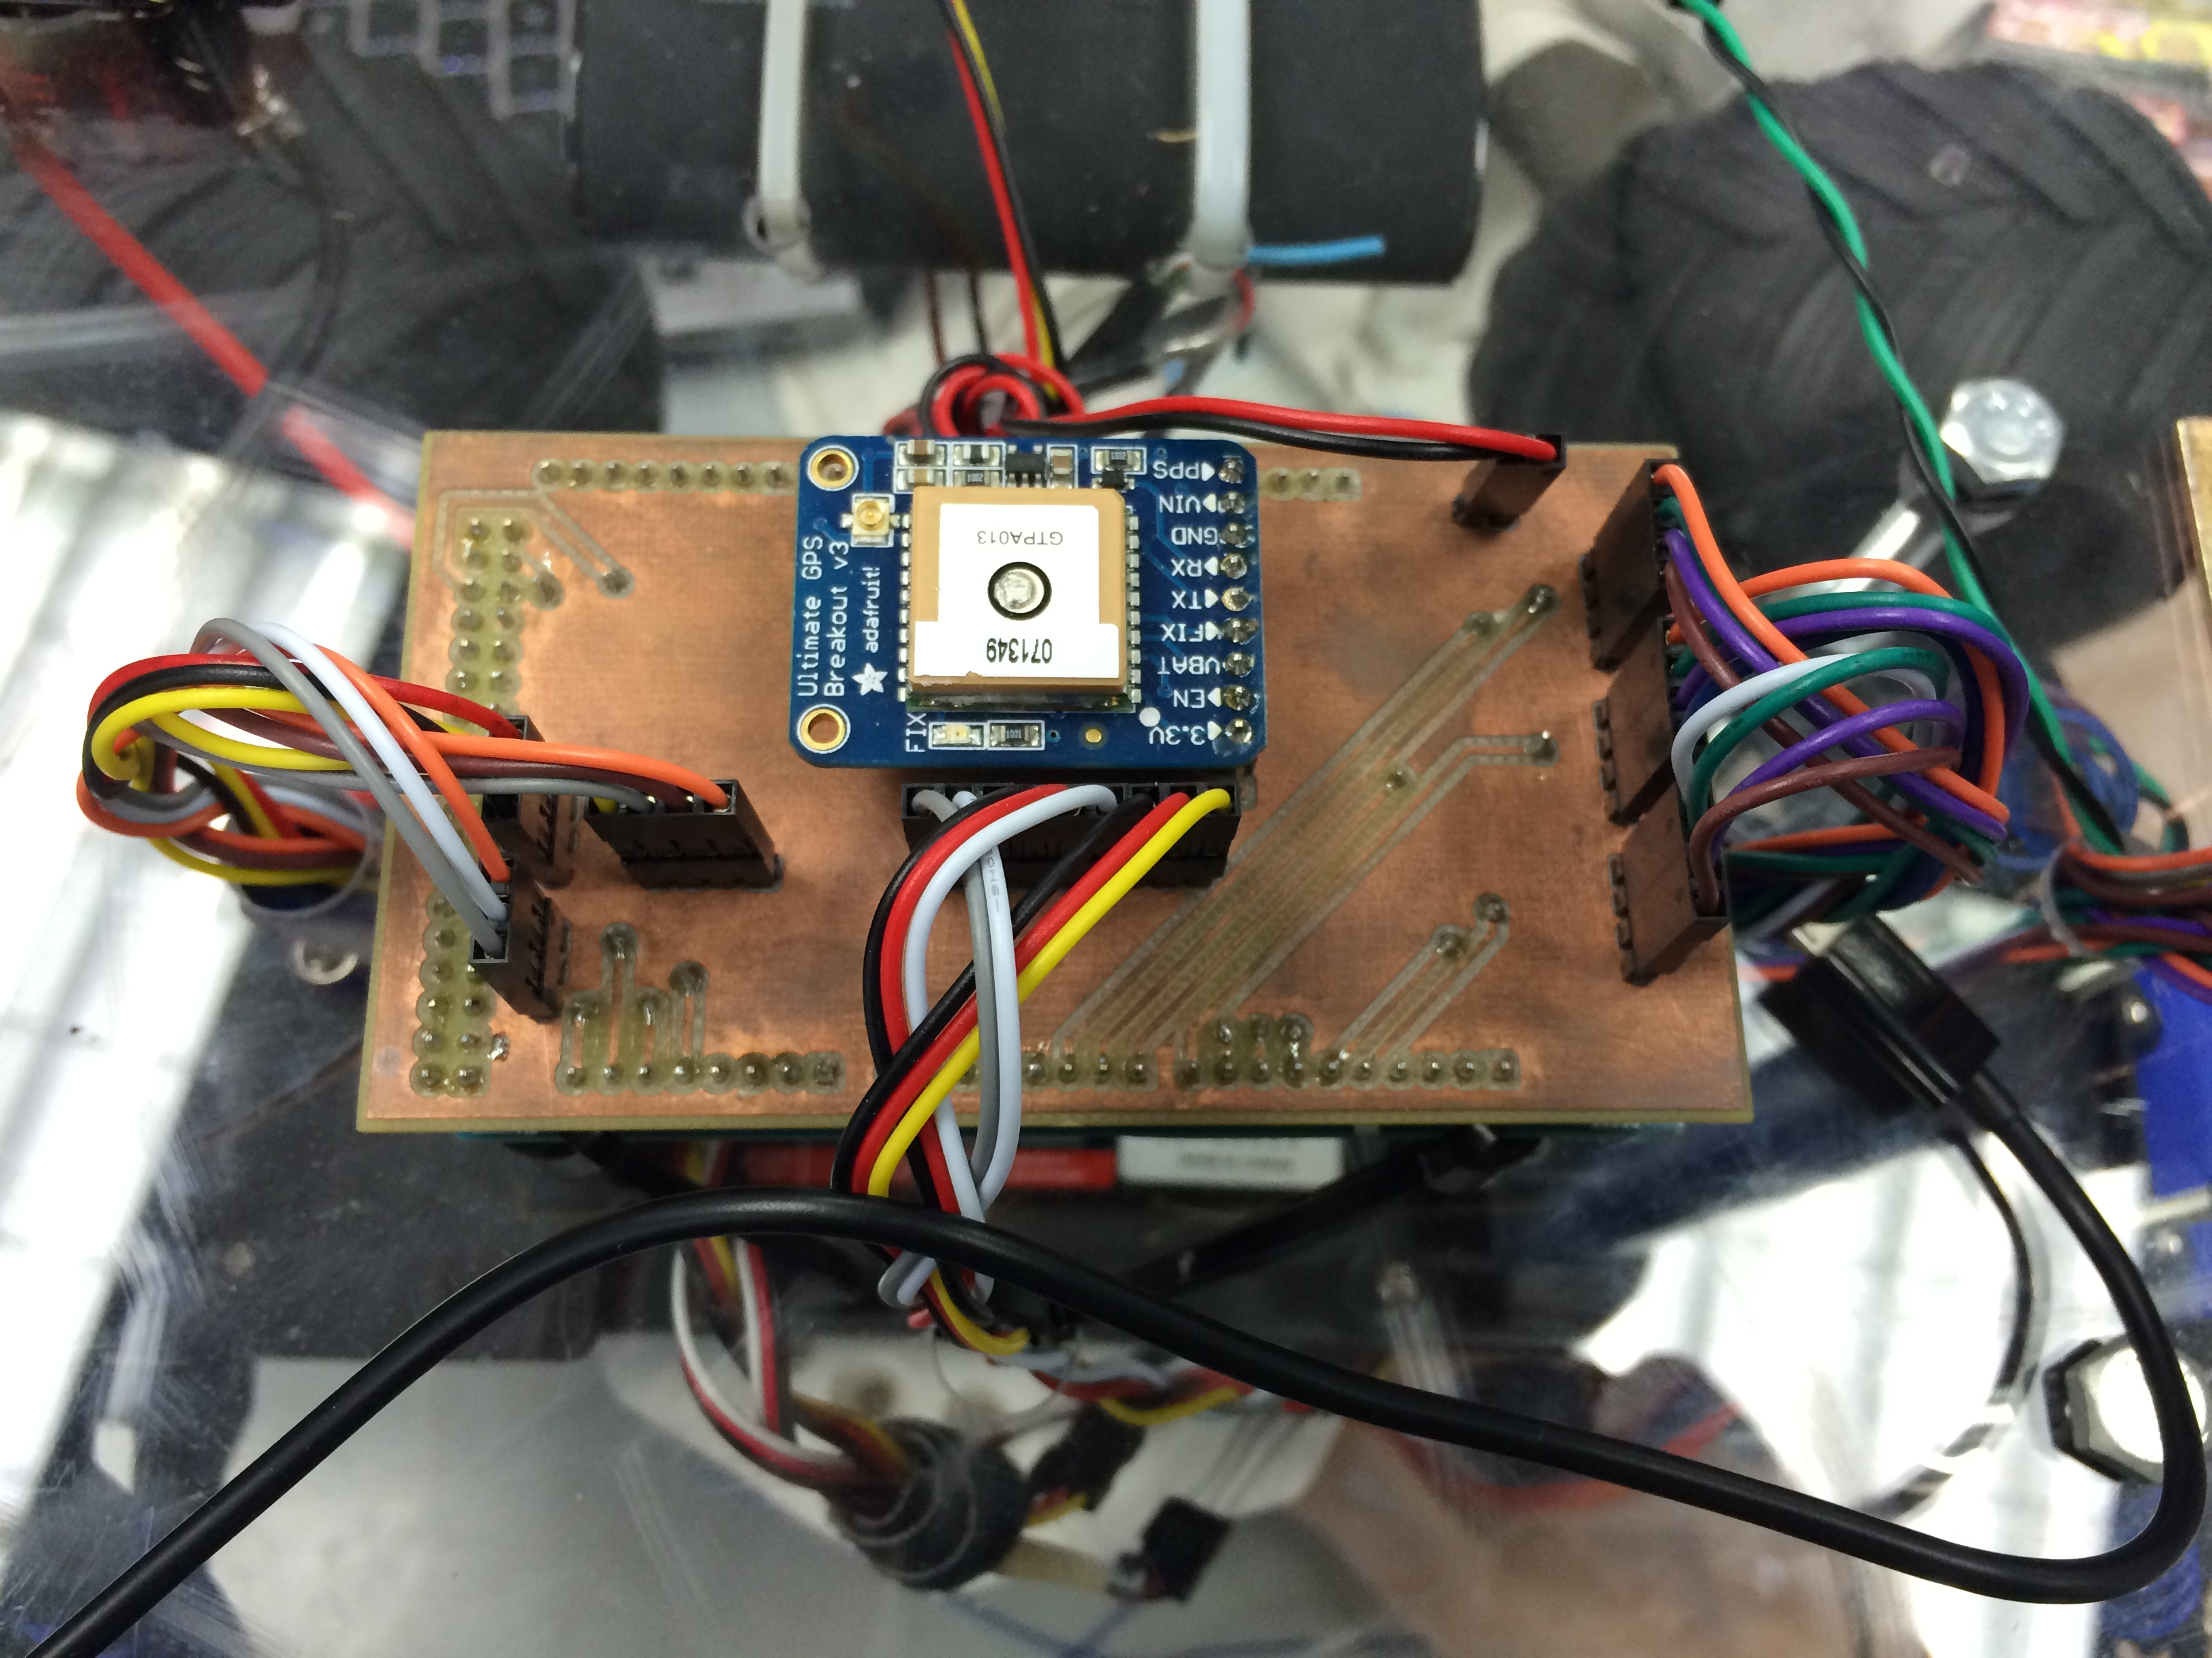

Figure 14: Finalized PCB neatly wiring up LILRO.

Vehicle Design
For vehicle design, we have designed the car while following two properties: simplicity and symmetry. Starting with the concept design we knew we would be using components such as a microcontroller, a GPS module, and a magnetometer. We designed the placement of the components to produce accurate results without interfering with other components, as well as making it easy for our team members to inspect and debug any issues we encountered.
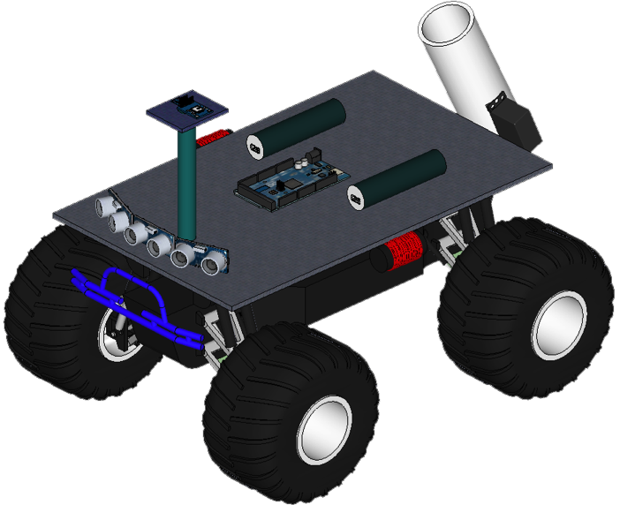

Figure 15: Mockup illustration of LILRO.
In order for the magnetometer to produce accurate and consistent readings, we allowed for the magnetometer to be located at the maximum distance from the largest source of noise, which happened to be the vehicle’s motor. Being constrained in a 20” cube, the magnetometer would be mounted on a pole isolated from the rest of the components.
The microcontroller, power supplies, and ultrasonic sensors would remain on the base in an orderly fashion. Utilizing three ultrasonic sensors, we placed the sensors at the front end of the vehicle, angled in a way to provide our 90-degree cone with a five feet distance of detection. Promoting symmetry, we have placed the microcontroller in the middle of the base, with our two component power supplies symmetrically centered along the sides of the microcontroller.
The antenna board is the only component to not promote symmetry but it is because at the last minute, we decided to utilize one antenna rather than two. Our original plan was to use two beacon detectors, allowing two antenna boards, placed at an equal distance from the front of the vehicle.
The payload delivery system is located in the rear of the vehicle, with the chamber of the delivery system being the largest component relative to the base of the vehicle. With the delivery system in the rear, it allows for a logical sequence of events when inspecting the vehicle.
Our components are attached to the base of the vehicle by zip ties. We originally had screws but the Lexan base, PVC pipe, and wooden delivery system did not have threads for a screw to become securely tightened. By utilizing zip ties, we did not have to use various sized screws, nuts and bolts, and it allowed for a cleaner, matching look. In addition to a nice look, zip ties allowed for easy re-construction, in case our car collided into any obstacles and the impact may have done significant damage to our vehicle.

Conclusion
Our team at Alternative Innovations set goals, while overcoming hurdles and creating a well-designed system. Integrating each part of LILRO’s design had its own challenges. The ultrasonic sensors used for obstacle detection were coded on a similar microcontroller that was used for the competition, but ultimately it was different. This resulted in incompatibility between the sensors and the microcontroller. This was a catastrophic error that was not foreseen, which resulted in LILRO competing blind. The antenna was designed to detect the beacon and it had its own issues as well, such as the proper activation of the payload system. With this all in mind, LILRO was still able to compete and finish.
Even though LILRO performed accordingly, there are many improvements to recommend. Higher quality ultrasonic sensors should be fully implemented and operational to be able to detect obstacles and avoid them accordingly. To do this, all coding should be done on the microcontroller that will be ultimately used in the final project. Another possible option would be to isolate the sensor’s power supply from the vehicle steering power supply. Equally important, a better antenna needs to be designed. The antenna circuitry was limited by the operational amplifiers that were utilized. Also, due to cost restraints, the payload was made out of wood, but it is our recommendation that the delivery system be 3D printed. A 3D printed payload would be tightly fastened and less prone to collusions and impact.
LILRO was a great learning experience for our team as we’ve acquired various new skills and learned to coordinate with each other in a team setting. We faced several challenges throughout the project, but through our team’s perseverance, we found ways to overcome them. By competing in this competition, our team was able to successfully simulate conditions that can apply to real life applications; IED detection and disarming.
References

[1] USA Today, IED casualties dropped 50% in Afghanistan in 2012.

http://www.usatoday.com/story/news/world/2013/01/18/ied-casualties-down-afghanistan-2012/1839609/

[2] GPS – NMEA Sentence Information. http://aprs.gids.nl/nmea/

[3] Magnetic Declination, Find the magnetic declination at your location

http://magnetic-declination.com/

[4] Traxxas, Programming Your Traxxas Electric Speed Control. http://traxxas.com/support/Programming-Your-Traxxas-Electronic-Speed-Control

[5] Adafruit, Adafruit Ultimate GPS Guide. https://learn.adafruit.com/adafruit-ultimate-gps

[6] Adafruit, HMC5883L Breakout – Triple Axis Magnetometer Sensor. https://learn.adafruit.com/adafruit-hmc5883l-breakout-triple-axis-magnetometer-compass-sensor
[7] Pozar, David M., “Microwave Engineering”, 4th Edition, Wiley Publishing, 2012

[8] The Lab Book Pages [online] Available:
http://www.labbookpages.co.uk/electronics/resNetworks/comparator.html

Appendices

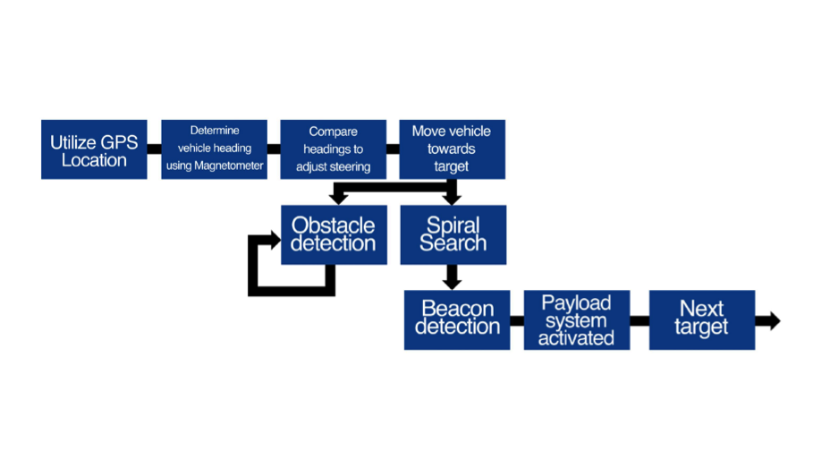

Figure 16: Software Overview.

Sensor Location | Distance from Obstacle | Servo Turn Radius  (in degrees)
 | 3 to 26 inches | 120
Right Sensor | 26 to 52 inches | 110
 | 52 to 80 inches | 100
 | 3 to 26 inches | 130
Right and Middle Sensor | 26 to 52 inches | 115
 | 52 to 80 inches | 100
 | 3 to 26 inches | 60
Middle Sensor | 26 to 52 inches | 70
 | 52 to 80 inches | 80
 | 3 to 26 inches | 50
Middle and Left Sensor | 26 to 52 inches | 65
 | 52 to 80 inches | 80
 | 3 to 26 inches | 60
Left Sensor | 26 to 52 inches | 70
 | 52 to 80 inches | 80

Figure 17: Obstacle Avoidance; distance to radii table.

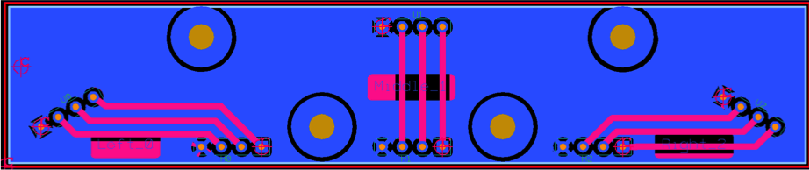

Figure 18: Ultrasonic Sensor PCB top layer layout.

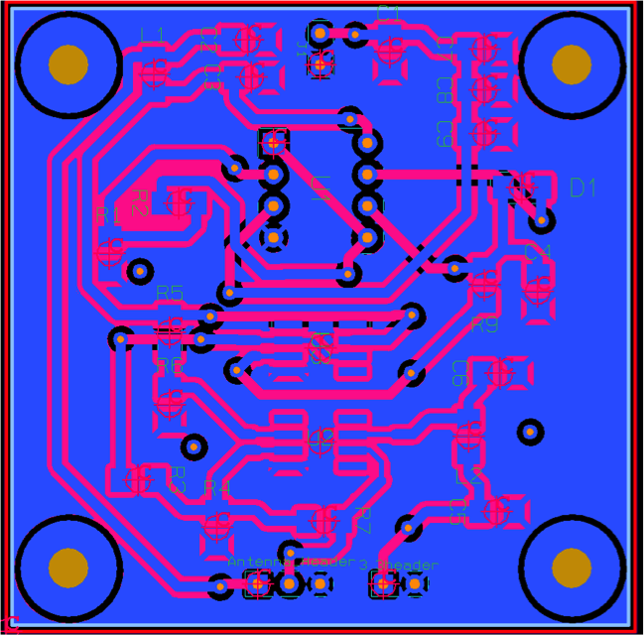

Figure 19: Antenna PCB top layer layout.

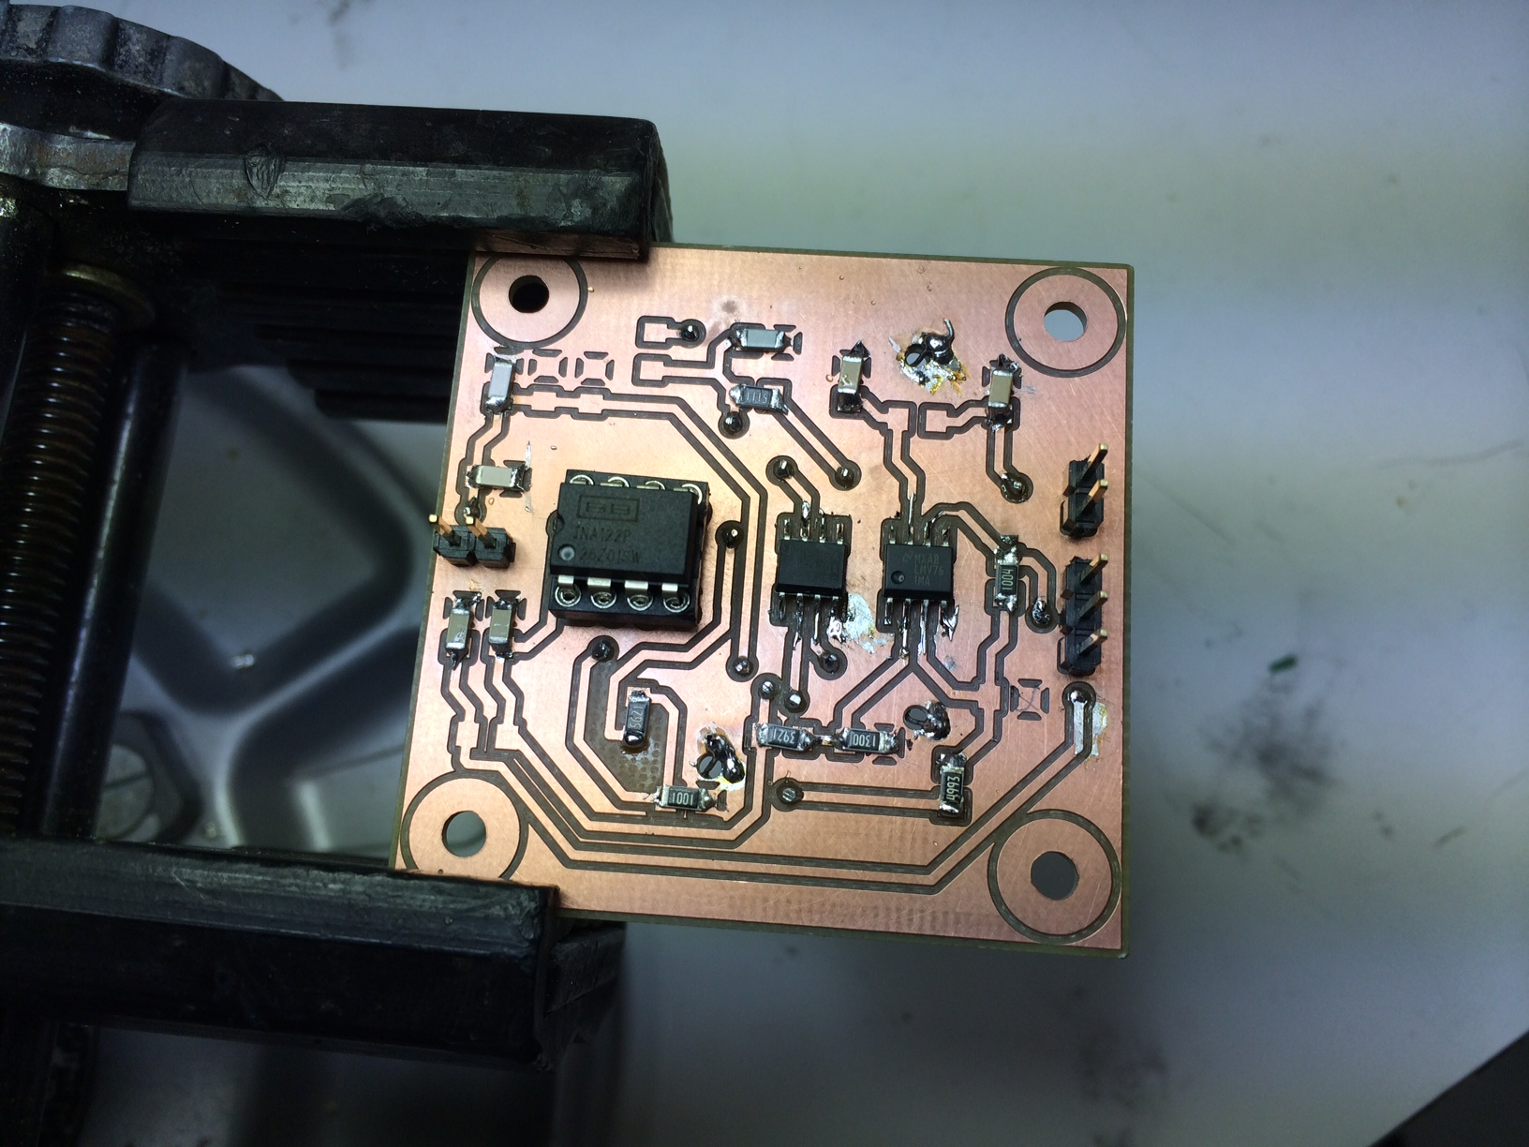

Figure 20: Finalized Beacon detection antenna PCB.

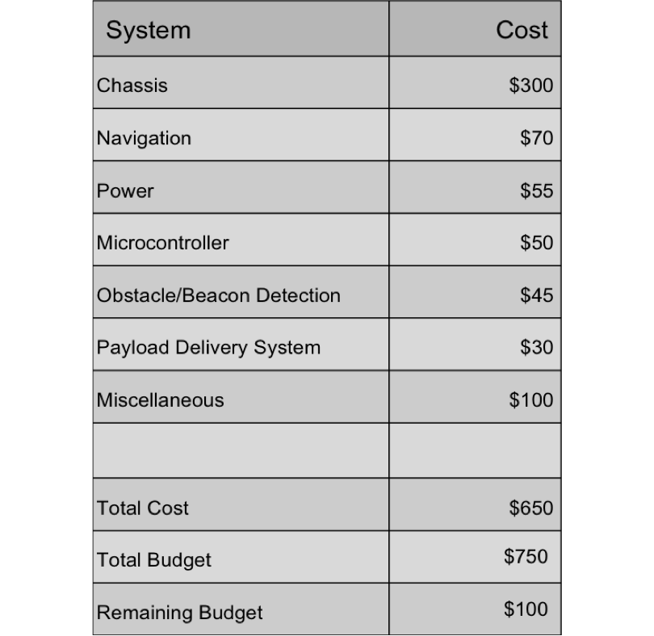

Figure 21: Team Budget Analysis.

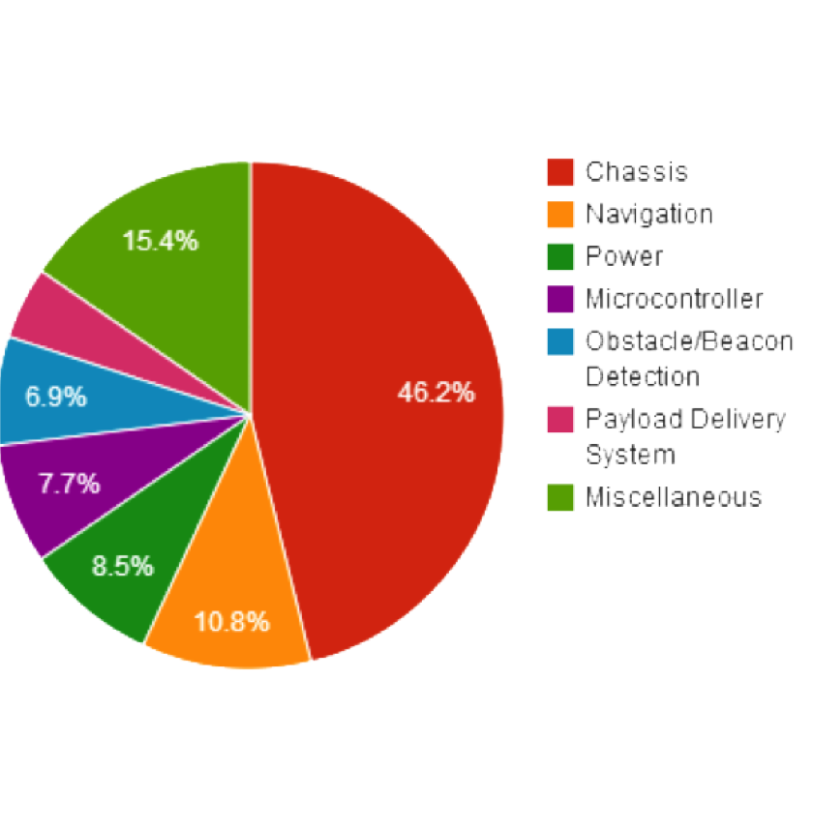

Figure 22: Budget Pie Chart.

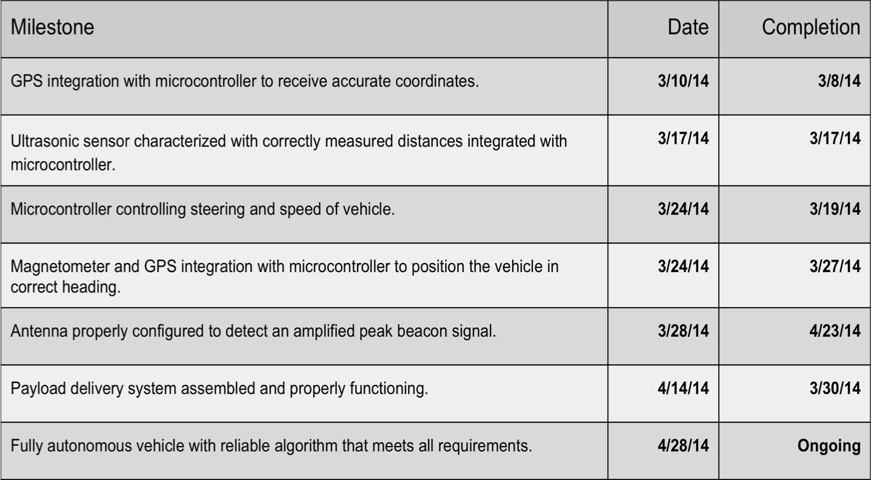

Figure 23: Our team’s milestones, which were key to our group’s success.

