**Sharknado**

Presents the

**Autonomous Payload Delivery Challenge**

**Engineering Team:**

Alex Egg

Andrew Goria

Alvin Lacden

Jeff O’Brien

Kevin Shinkle

Daniel Tarantino

Submitted to:

John Kennedy and Lal Tummala

**Design Co. Ltd, San Diego, CA**

**Abstract:**

Sharknado is charged with the task of designing and building an autonomous payload delivery robot that will be able to locate different beacons, travel to the locations, deliver the payload (in the case of the challenge, golf balls), and return to the starting location in under two minutes. In the past engineering teams have bought their chassis and used the motors and wheels that had come with it. Sharknado has decided to design our own chassis made from aluminum and buy our own motors and wheels and integrate them on our own. Our goal is design and build the autonomous robot that will fall under the given requirements in the most efficient way possible.

**Project Description:**

The objective of the project was to ensure the robot would drop three different payloads utilizing the three components of our design: locomotion, sensors, and payload delivery.

Our robot will operate in differential drive utilizing 4 gear motors with 19:1 gear ratios and capable of 500 rpms and 84 oz-in of torque. The gear motors will be connected to Dagu Wild Thumper wheels with a diameter of 120mm. With the motors and that size diameter wheels we will be able to move the robot faster than 2.5 m/s we calculated we needed in order to complete the challenge. We will then use motor controllers that will operate with pulse width modulation outputted from the microcontroller as a means for direction and speed. Only two motors with encoders are necessary which will tell the microcontroller the speed at which the motor is rotating which will be used as feedback to ensure the robot will drive straight.

The microcontroller we will be using is the Arduino Due containing a 32 bit Cortex-M3 ARM microcontroller. This will allow us to send the signals to the motor controller and receive the signals from our sensors which include the GPS, ultra-sonic sensor, magnetometer, and antenna, and output signals to the payload delivery system.

Our robot will use GPS tracking to locate the general location in which to travel while the ultrasonic sensor will use sonar to locate any objects that might be in the way of the robot. As the robot gets nearer to each beacon, the antenna will pick up a frequency of 80 kHz to help triangulate the exact location of the beacon which will then tell the microcontroller to signal the payload delivery system to drop one golf ball. Our payload delivery system will use a servo motor and most likely PVC pipe to drop each golf ball.

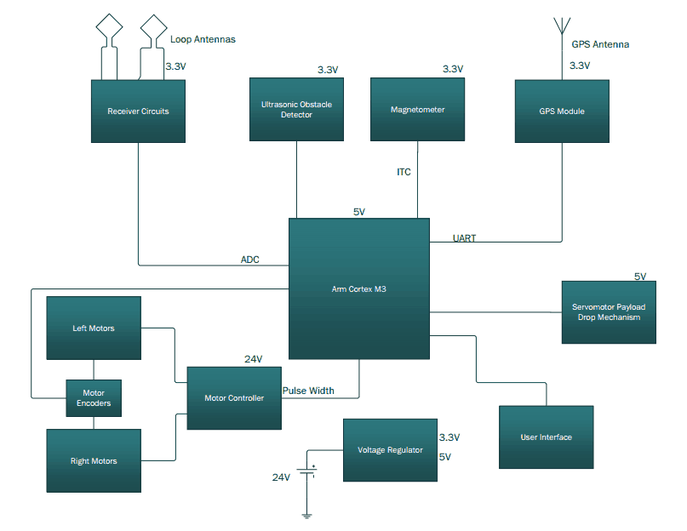

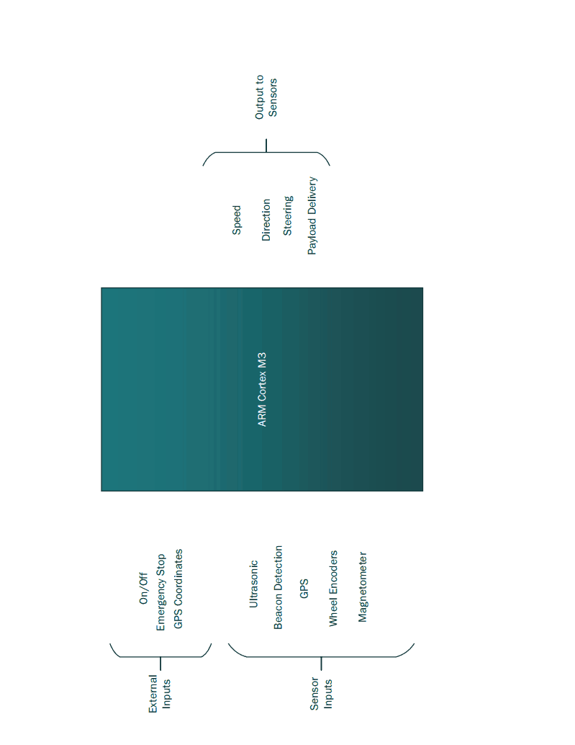

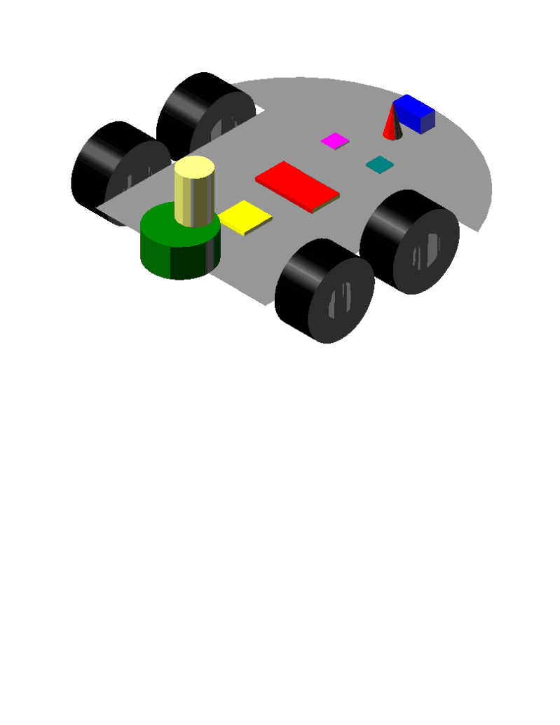

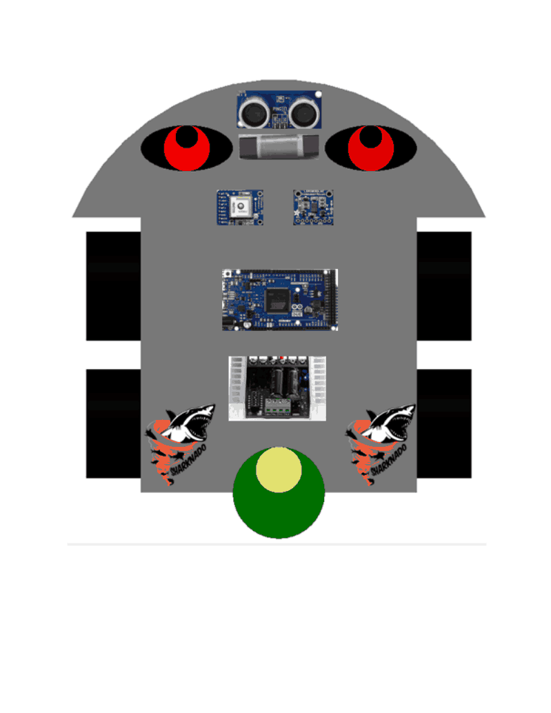

**Specification of Performance Requirements:**

* The robot must autonomously move to the specified locations by GPS
* The robot must detect any object in its way and successfully avoid it
* The robot must detect the 80 kHz signal emitted by each of the three beacons by antenna
* Delivery of the payload must be within a 1 foot of the location of the beacon
* Speed of the robot must be fast enough to reach each beacon and back to the starting location in 2 minutes or under
* A power switch must be available that would mechanically shut down the robot at any given time

**Testing Procedures:**

Chassis:

Verify the appropriate and functional installation of the motors and wheel on the custom chassis. Ensure that the Chassis is able to move forward and backward and that motors have enough torque to allow differential drive turning and capability to move from a dead stop. Test interface with microcontroller to ensure that chassis has the ability to drive straight based upon input PWM and follow navigation adjustments sent to the motor controller.

Motors with encoders:

Testing Motors with Encoders: First test the motors without the ARM microcontroller and just use the power supplies in the lab. Using the power supplies, I can determine what kind of torque and speed we can get out of the motors and if they are up to spec. Next connect the motors up to the motor controller and continue testing using the power supplies and function generator to test speed and direction changes. The final testing would involve the ARM microcontroller and the assembly of the chassis and wheels to make sure the robot moves the way we want it to.

Motor controller:

In order to test the motor controller, we will first try to get the wheels moving by sending a pulse width modulation to the motors to get the wheels turning. Then we will test to see if the whole vehicle will move straight which is done by sending all the motors the same PWM. Next we will vary the PWMs so that the car can actually turn and move in other directions. Finally we will test to see if the motor controllers can still do all the above while incorporating the GPS and payload dropping device as well.

Payload Delivery Mechanism:

Verify proof of concept by creating a prototype to test without a Servo Motor. Integrate the Servo Motor and ensure the motor has enough torque to turn the payload delivery system as need and test the range of motion of the servo motor. Test the entire payload delivery system to ensure dependability 99 percent of the time. Install the payload delivery system onto the chassis and test the interface with the microcontroller.

Power Supply:

The power supply can be tested by creating a resistive circuit that will require a greater current output than what we expect our vehicle to use. If it can output this current and keep its voltage for a long duration without any difficulties then the battery should be viable. After doing this exercise its charging capabilities can be tested.

Beacon Receiver:

Set up function generator as a mock beacon to test ferrite rods resonate frequency and ability to pick up 80kHz signals. Once resonate and matched the ferrite rods will be connected to gain circuits and tested by being placed on a vehicle on opposite sides. The vehicle will be moved around to test how well they can triangulate a position based on their varying voltages.

Magnetometer:

In order verify the functionality of the HMC6352 magnetometer; we will be interfacing it with I2C. The HMC6352 will be wired it into the ARM Cortex-M3 microcontroller; from there information will be sent to a computer via USB. To test the performance of the HMC6352 we will be simultaneously using an adjacent compass in order to validate the accuracy of the HMC6352, as well as, comparing our results to the manufacture specifications.

GPS:

In order to test the GPS, we can first test that the GPS can track the position of the vehicle. We then will test how accurate the GPS is by creating a scatterplot in MATLAB. Then we will test the GPS attached to the overall design and also test if it can be accurate in different types of conditions such as heavy clouds or wet grass.

Sensors:

In order to test the ultrasonic sensors, we can see how accurate it is by testing the distance that it can sense objects in front of it. Then we will mount the sensor to the chassis and test to see if the whole vehicle can sense the obstacle and then finally avoid the obstacle.

**Benchmarks:**

The finished project will be the BUD robot that will be built and operated according to our finalized design. The robot will move at sufficient speed and torque due to the DC motors that should run at the minimum of 390 RPMs. The ARM Cortex-M3 microcontroller will receive signals from GPS to both establish current location of the BUD robot as well as identify the locations of the three beacons and communicate to the motor controller to move in those directions. The ultra-sonic sensor will tell the microcontroller if there are objects in the way and in which direction should the robot turn in order to avoid observed object. As the BUD robot nears the location of each of the three beacons, the antennas will receive the 80 kHz signal and determine when to drop the payload based on the strength of the signal. The payload delivery system will then use a servo motor to rotate a disc allowing the golf ball to drop from the backside of the robot. The BUD robot will repeat this process and return to the starting location with enough speed to perform the Payload Delivery Challenge in under the allotted time.

**Project Management:**

In order to get this project finished, we must be organized be able to complete each task quickly so that we can move on to the next task because most of these tasks need a previous task completed in order to start. We started by researching parts and deciding the general design. We then moved on to ordering parts and started the section of the project that we could do while waiting for the parts such as the working on the antenna and experimenting with code for the sensors. While we were discussing our

general plan, we have decided to build our own chassis instead of buying an already built one. We have designed the body using solid works which will be cut for us using the water jet cutter. As soon as we get the body built and get our wheels and motors in, we can assemble all those together to have the base for our vehicle. Once our motors and motor controllers come in, we can get the car moving and turning. While we are building the base of the chassis and getting it to move, we will be working on the sensors, antenna, and GPS coding so that our vehicle can avoid obstacles and go to specific point. If we can get all that working together, we can combine that with our payload dropping device which will be made using a servo motor and PVC pipes. Then we will combine all these parts together so that the vehicle can autonomously go to 3 beacons and drop 3 golf balls at those beacons and go back to the starting point. These tasks will be difficult to accomplish and we will split the task among the six members to get this done as fast as we can. In the following Gantt chart we will attempt to complete this project using this estimated schedule to stay on track.







**Milestones:**

1. Chassis Built 3/13/2014

We first must have the body designed using SolidWorks and use a water jet cutter to cut a piece of aluminum into the body of our car. Then we must attach the motors and wheels to complete the base of this car.

1. Chassis drives straight 4/8/2014

After we get our motors and motor controllers working, we must now get our chassis to drive straight. This is done by have both sides of wheels have the same PWM.

1. Chassis turns with the PWM of motor controllers 4/9/2014

By changing the PWM of the motor controllers, we can control the turning by making the left and the right wheels a different PWM.

1. Have the chassis pick up the 80kHz signal and go to a GPS coordinate with magnetometer 4/18/2014

After getting our GPS and antenna working correctly, the chassis will be able to find the signal from the beacon and drive to it based on the GPS coordinates.

1. Successfully avoid obstacles with ultrasonic sensors 4/23/2014

After getting our ultrasonic sensors to be able to detect and avoid obstacles, we can have them mounted to our moving chassis and have the vehicle able to avoid obstacles so that it can get to its destination.

1. Successful payload drop with moving chassis 5/1/2014
   1. After getting our servo motor to move our payload dropping device correctly, we can mount the device to our moving chassis and have the device drop golf ball at a correct target.
2. Do previous milestones to complete the course

To complete the project, we must get all the previous milestones to be working together to be able to get the autonomous car moving on its own to the 3 beacons, drop golf balls at all 3 beacons and be able to come back to its starting position.

Budget:

|  |  |  |
| --- | --- | --- |
| **Part** | **Cost** | **Quantity** |
| Custom chassis | $35 | 1 |
| Magnetometer | $41.68 | 1 |
| GPS | $56.60 | 1 |
| Motors w/o encoders | $49.90 | 2 |
| Motors w/encoders | $95.24 | 2 |
| Motor Controllers | $172.78 | 2 |
| Servo motor | $30.00 | 1 |
| Payload mechanism/dropper | $15 | 1 |
| ARM Cortex-M3 | $44.95 | 1 |
| Antenna | $3.24 | 3 |
| Battery | $40 | 1 |
| Ultrasonic sensor | $30 | 1 |
| Wheels | $41.24 | 4 |
| Motor mounts | $15.90 | 4 |
| Misc | $2.16 |  |
| **Subtotal** | **$673.72** |  |
| **Total budget** | **$750** |  |
| **Budget remaining** | **$76.28** |  |

