

Design Team:

Rommel Cabal

Spencer Cadden

Derrick Celestino

Eric Leon

Michael Spinali

Sponsored By:

Dr. Gordon Lee

Submitted To:

John Kennedy and Lal Tummala

Department of Electrical and Computer Engineering

San Diego State University

Spring 2014

Abstract

Robots have recently been created to interact with a human, which allows them to develop good communication skills, especially for those that have some type of disability. There is a lot of general information that students need to know in order to graduate from San Diego State University with an Electrical Engineering degree. Many students are forced to do their own research or ask an administrative, but students are still often confused and unaware of the necessary actions that they need to complete to achieve their degree. We plan on bridging the gap between the university and students by creating a robotic head that will be able to listen to questions regarding the requirements to earn a Electrical Engineering degree. The user will be able to ask questions using a microphone, and the robot will produce the necessary output using a microcontroller, various motors, and speaker. The robot will consist of a microcontroller that will produce the necessary pulse to communicate with the various motors, which will mimic facial expressions and speech.

Project Description

Human machine interactions involves designing a machine to produce a desired output based on the user input. The goal is to develop a machine that will be able to respond with facial expressions and speech given a specific question. The user will be able to verbally ask the machine a question. The machine will then give a facial expression and a verbal response to the question that was asked.

The design will include a UDOO microcontroller, 16 motors, and a human face. The microcontroller will take the user input, which was given verbally, and identify key words within the question to determine the proper response. The microcontroller will then produce the corresponding pulse width signal that will communicate with the 16 motors to achieve the desired facial expressions. The microcontroller will be able to control the movement of the eyebrows, eyes, lips, jaw, and neck. The signal that was sent by the microcontroller will control which motors will function and how much torque will be exerted on the face. The coordination between the active motors and torque will produce different facial expressions. If the question was not understood a default response will be given.

The design also includes a voice recognition software that will communicate with the microcontroller. Not only will the microcontroller be able to communicate with the motors to produce facial expressions, but it will also be able to produce a verbal response with the aid of a voice synthesizer program.

The robotic head will have its own power supply to power all 16 motors. The power supply chosen will be power all 16 motors at once. A internal structure will also be created to position the motors in the correct position and to insure the durability of the robotic head is adequate. An external mold will be used as a external structure. A silicon skin will be created and connected to the motors to make the facial expressions as real as possible.

If time permits we would like to incorporate facial recognition as well using a camera and other sensors. The camera will be able to track the person that is asking the question. The robot will also be able to determine if the person is a new user, or a previous user.

Power

Supply

Udoo

Motors

Camera

Speakers

Mic

Skin/Head

Audio Signal In

Motion Signal In

Audio Signal Out

Rotation

Sound

Facial Expression/

Head Movement

Human Voice

Body Movement

Movement

Signal Out

Power

Block Diagram

Input/Output Diagram

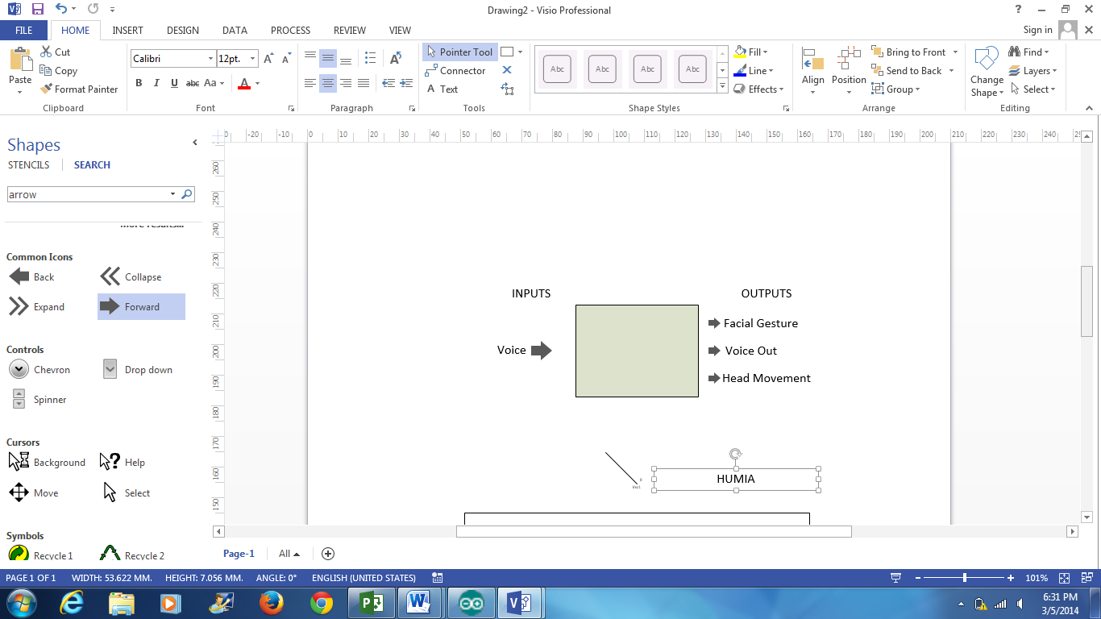

Robotic Head

Mock-Up Illustrations

The finished product of our design will mimic the structure and movements of a human head. While the color and shape may vary, our design will use a silicone mask similar to those shown below:

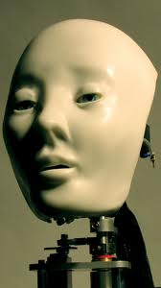 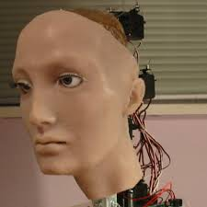

The structure of our HMI robotic head will be a hollow 3D printed skull. The CAD design for the skull is shown below:

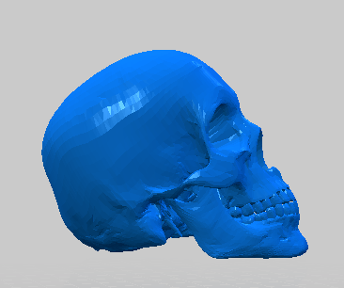 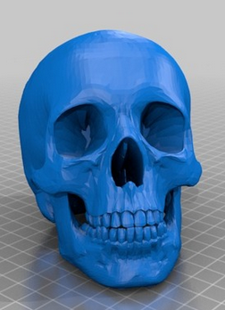

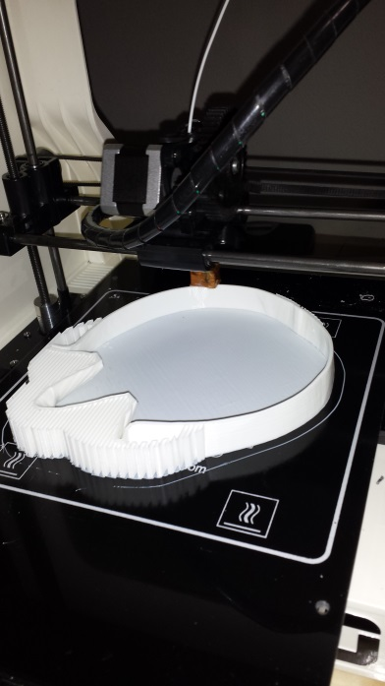 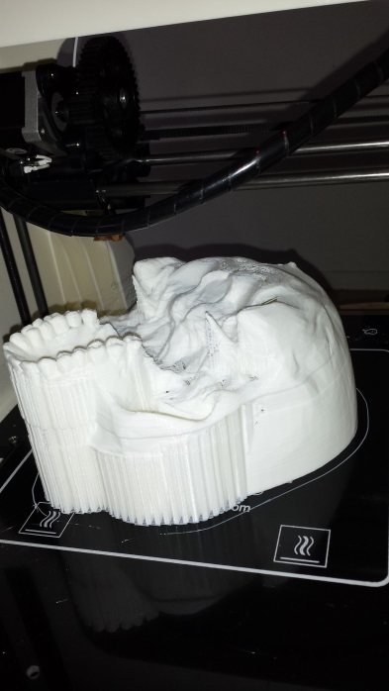

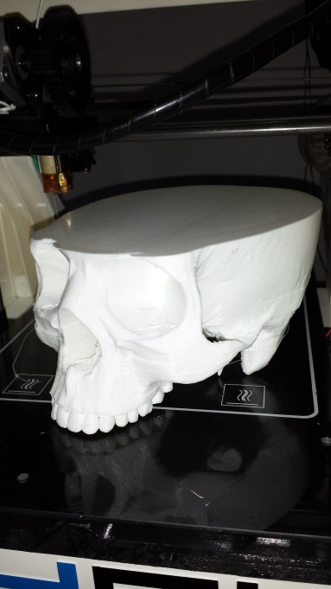

A separate CAD file was created to show the general placement and number of the motors within the skull. It has been determined that a total of 16 motors will be used to execute the desired functions (4 motors for the eyebrows, 3 for the eyes, 1 for the jaw, 6 for the mouth, and 2 for the neck).

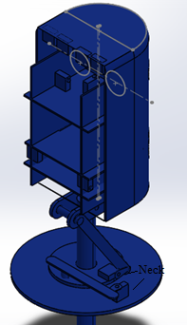 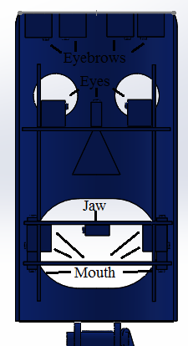

Performance Requirements:

Our goal for this project is to design and build a fully functioning natural language based robotic head for human-machine interface applications. To show that the robotic head was properly demonstrating the design goals, the following requirements were set by Dr. Gordon Lee and the SDSU Electrical Engineering Department:

* HMI robotic head must be able to listen to at least 6 simple voice commands and questions and then identify specific key words within each.
* Upon identifying the question, the robotic head must be able to vocally respond to them and have the correct corresponding mechanical movements.
* The motors will manipulate a silicone mask to mimic the expressions and emotions similar to that of a human.
* These movements must be completed using motors directed by a microcontroller.
* The system will have a backup response when an inputted question is not understood.
* The structure of the robotic head must be of a size of equal likeness to that of a human head.

Optional Performance Goals:

* Use a camera and sensors to track the person asking the question.

Testing and Verification

* Producing a high performing, efficient design closely aligns with testing and verification procedures. Although the overall design will be tested and benchmarked thoroughly, individual components will require this same rigor. Systematically modularizing the design, and performing such tests, helps produce a high performing design that exceeds design requirements in an efficient manner. The design has been broken up into the following categories that will be tested periodically as the project progresses: mechanics, material, power, software, and functionality.
* The mechanics section of the design encapsulates the motors used, structural integrity, and physical architecture. The motors will be tested to ensure they can respond to the desired facial expression commands in a proper, reliable manner. In addition, stress tests will be performed to ensure the motors are moving loads that lead to normal wear. In this way, the stability of our design can be increased as well as the durability. The structural integrity will be analyzed, by performing stress tests, to ensure our robotic head frame maximizes both space and strength. The physical architecture closely aligns with structural integrity, in that motor and mechanics placement will be iteratively analyzed. By iteratively analyzing this aspect amongst all members, we can create a proper foundation for high level development.
* The material module of the design ensures that the materials used are durable, fully functional, and can maintain a level of high performance. Specifically, all plastics used will be over analyzed using Solid Works so that the materials can exceed the needs of the design, in particular those of the mechanics division. The silicone rubber used for the synthetic skin will be stress tested in a demanding environment. This ensures a proper material was selected and more importantly was reliably synthesized. All adhesives and similar materials will be assessed in test environments to ensure they hold up to the general manufacturer specifications given.
* The power division of the design, entails ensuring all electrical components receive the necessary power in demanding scenarios. Specifically the power supply of Humia will be analyzed and verified to ensure that proper power is given to the microcontroller and motors in all possible scenarios. To achieve this, the scenario where all motors are in stall (require maximum current) will be assessed. By overdesigning to accommodate this almost non-existing situation, normal-operation power requirements can be reliably guaranteed.
* Testing the software components of design entails modularizing the software and testing those areas. In particular, the user input interface, runtime framework, inter-processor interface, and I/O interface will be verified. These software divisions will be verified in an overly-demanding environment. Over designing in this way, helps prevents software failures, reduces stress on the design, and increases efficiency.
* Functionality testing, includes final testing and iterative optimizations of previous design components. Once all components are tested, a functionality test will be performed ensuring the quality of the product. In addition, as suggested by previous sections, iterative optimization analyses will continuously be performed on all design components. Although, resources and time spent on such testing are significant, the results ensure high levels of quality, innovation and performance.

Benchmarks

* Benchmarks closely align with testing and verification and as such will be leveraged. Power benchmarks will be created equating to efficiency, maximum output current, and corresponding maximum duration (time). Software benchmarks will be created, which will help abstract load performance, performance vs-time, and response time. Similar mechanical and material benchmarks will be created to help establish bounds to our design performance. This process of setting benchmarks helps ensure quality and reliable achievement of design requirements.

Project Plan

The purpose of this project is to design and build a natural language based robotic head that will be able to listen to simple voice commands and simple questions. The robotic head will then respond by talking and showing emotional expressions mechanically. We are improving upon last semester’s design of the robotic head, which was only capable of performing facial gestures according to the emotions inputted by the user. The ultimate goal is to use less motors, less money, and more functionality. To achieve this goal, we chose an alternative approach. We chose to use the Udoo microcontroller because it is a combination of the Arduino and Raspberry Pi microcontroller, and has the functionality we need for speech recognition. The Udoo will also be able to drive the motors that move the intricate parts of the face. To cut manufacturing costs and time, we will implement rapid prototyping using a personal 3D printer. Having our own printer would allow us to design different parts for the robotic face, such as housing for the motors, by using Solid-Works software and print the parts right away for testing. The way we want the user to interact with the robot is to have him/her ask a question that an electrical engineering would ask, where the built in camera would identify and remember the person who asked the question. Once the robotic face has identified key words from the question asked, the robot will then output the answer through a speaker. The movement of the lips, mouth, and eyes will be correlated with the sounds.

Project Management

Humia Project Gantt Chart



Humia Milestones



Budget



|  |  |
| --- | --- |
| Item | Price |
| Udoo & Camera | $200 |
| Motors | $150 |
| Molds | $150 |
| Filament | $50 |
| Power Supply | $50 |
| Hardware Components | $50 |
| Miscellaneous | $50 |
| Total | $700 |

