Abstract

Capsule Corp will be designing a robot for the Autonomous Payload Delivery Challenge at San Diego state university. Our robot will use GPS coordinates to find beacons placed randomly in a field. If our system detects an object in our path using ultrasound, we would use the differential drive system to make very precise turns to circumvent it and then continue towards the beacon. Once near the beacon, our custom built antenna system, two antennas mounted on opposite ends of the front chassis, will pinpoint its exact location. This is done by finding the exact point at which both antennas pick up the same signal strength, while rotating on the spot using the differential drive system. Once close to the epicenter, our rear-mounted, servo operated delivery system will drop a payload directly on target before moving on to the next beacon using the GPS coordinates. After all the beacons have been delivered a payload, the robot will return to the starting location which it finds by calculating the return vector. All The computations are made by a programmed STM32 discovery board hooked up to all of its components, providing a single focal point for all signals.

Project Description

Our system will be designed and assembled to resemble the mock up images on figures 2 and 3. The frontal attachment includes our antennae and an ultrasonic sensor as seen on figure 3. The frontal placement was due to the fact that all objects detected will be encountered directly ahead of us. Once the sensor detects an obstacle, it will send a signal to halt the motors. To do this the signal must travel to the microcontroller, as seen in figure 1, which would then alter a signal to the Sabertooth controller that controls forward motion to the motors. The antennae, as shown in figure 3, would detect a beacon signal at 80 kHz from about 6 feet away. These components will be completely designed from scratch and broken down into 4 parts, as seen in figure 1. These parts will collect a signal, amplify it and regulate it to get a clear output. The scalar will then adjust the analog output based on proximity. This clean, amplified signal will be sent to an analog to digital converter in the microcontroller. Once a signal is detected on the antennae, the microcontroller will halt the motors and signal the Sabertooth to rotate on the spot to find the exact point where the two antennae pick up the same signal strength. This ensures the beacon is directly in front of the robot.

The GPS and magnetometer are elevated off the ground on towers in figure 2. This is to ensure the circuitry and motors do not affect the accuracy of their readings. Each device interfaces with the microcontroller directly: The GPS using UART and the magnetometer using I2C, as seen in figure 1. The GPS will provide our robot with headings that can be used to calculate vectors for locomotion. We would use our magnetometer to find out where it is facing. Using the FT232 and a laptop, we can download GPS coordinates into our microcontroller.

Payload delivery will be rear mounted as shown in figure 2 and 3. The payload delivery will be directly interfaced with a GPIO port as seen in figure 1. When the microcontroller gets the strongest signal strength from the antennae to show that we are right next to the beacon, the microcontroller will halt the motors using the Sabertooth and then signal the payload delivery. Sending a pulse width modulated signal to the servo on the payload, it will turn 180 degrees, turning a cup holding a ball and dropping it.
The Sabertooth controller, seen in figure 1, is integral to the chassis as well as the motors and encoders. These parts will handle locomotion. The Sabertooth is the central module in the system. It interfaces directly with the microcontroller, the motors and the encoders. It controls the speed and direction of the locomotion, which are decided by pulse width modulated signals from the microcontroller by two respected I/O pins. The encoders will feed back into the microcontroller and Sabertooth to show the speeds of each side of the robot’s wheel spin. The microcontroller can contrast these and adjust the speed of the robot while the Sabertooth adjusts the distribution of power to each side of the car.

Block Diagram
Power Circuitry
PC
DC Voltage Regulator
Battery
8.4V
Payload
Delivery
5V
Drop Command

Speed

Forward/Reverse

Left/Right

Speed

Command/Debugging

UART

FT232RL
Signal Strength

Distance

RPM

RPM

3.3V/USB
I2C

Magneto-meter
3.3V 0.1mA
Ultrasonic
Range
Finder
3.3V 3.1mA
UART

GPS
3.3V 56mA
VLF Antenna
Scaler
Rectifier
Amplifier
LC Antenna
5V 3.1mA
8.4V Input 5V Output
ARM Cortex
MicroController
GPIO

GPIO

GPIO

GPIO

GPIO

GPIO

GPIO

Sabertooth
Motor Controller
Motor
Encoder
Motor
Encoder
Motor
Motor
Motor
Motor

Figure (1)

CONCEPTUAL DESIGN
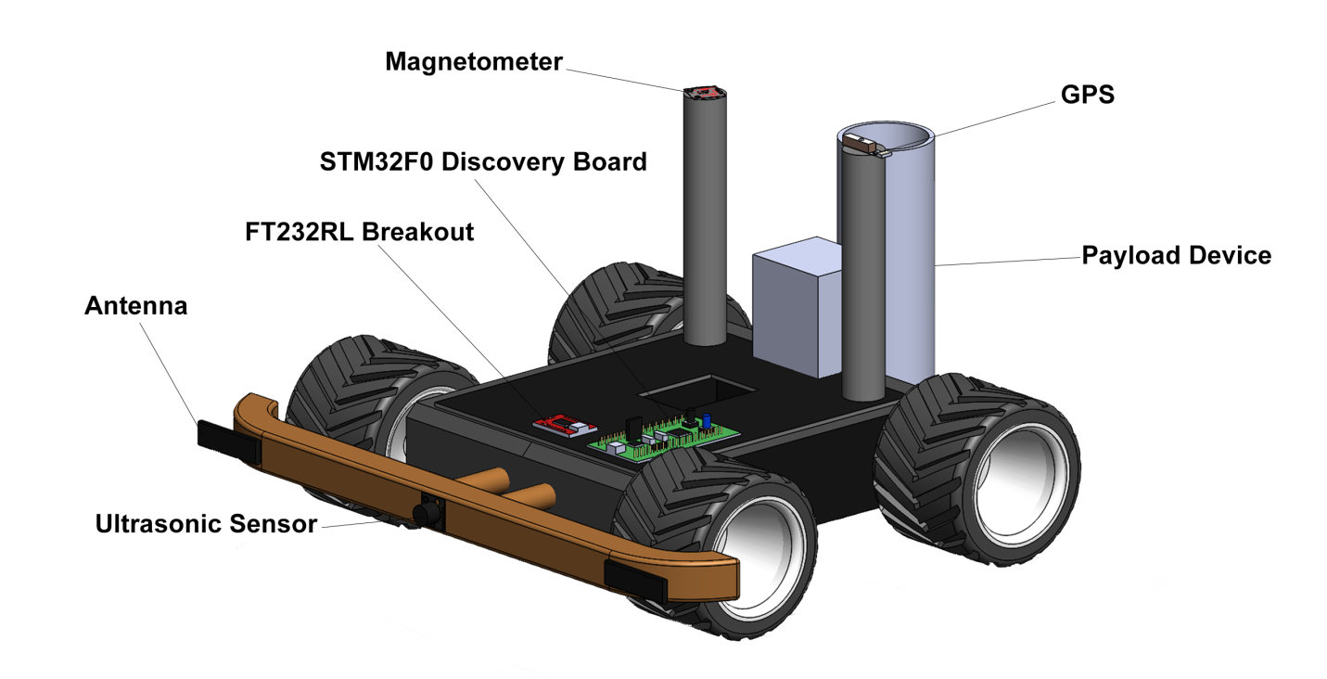
Figure (2)
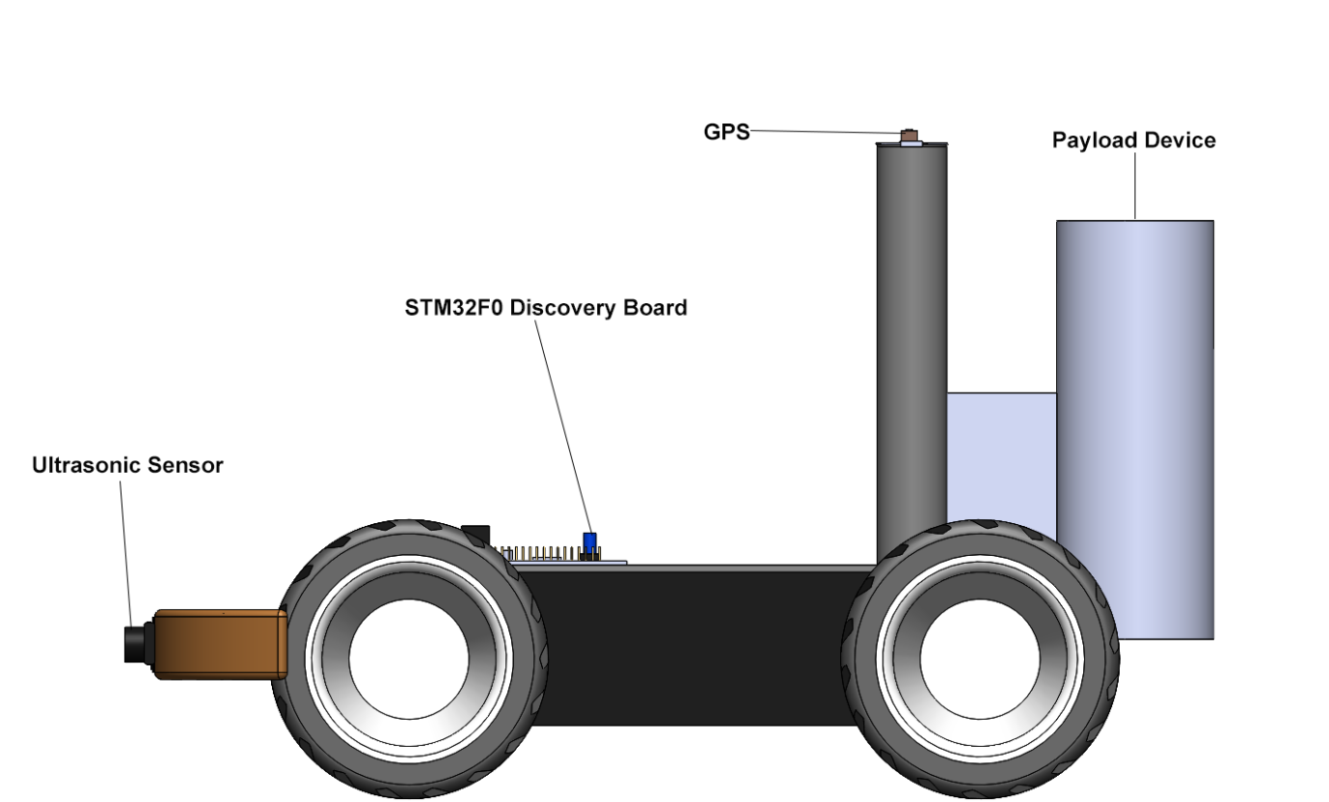
Figure (3)
PERFORMANCE REQUIREMENTS

- Before we start the competition, GPS coordinates are entered into our program through the FT232 Breakout Board corresponding to 3 locations. When the event starts, the vehicle must be completely autonomous once it has left the start box. Once the GPS coordinates are processed, our system will pick the closest destination, plot a bearing and set forth on a direct vector to the target without human aid.

- Obstacles are scattered throughout the field of play so some form of obstacle avoidance is needed. When one of these obstacles is encountered, the robot will use an object avoidance algorithm that will help it steer clear of the obstacle. Once the obstacle is cleared, the processor will reassess the GPS coordinate to calculate a new vector that will lead it to the target, plotting a new course

- An 80 kHz signal must be detected by the autonomous vehicle so that the beacon can be found. The signal will be picked up by two antennas that are mounted on the front bumper of the chassis. It will be able to determine the point at which the signal is equally clear on both antenna, meaning that the beacon is directly ahead, and drive towards it.

- Payload must be drop within the marked target ring to acquire full points. The payload device will be mounted on the back of our chassis and be able to drop golf balls. A servo will drop each ball by rotating an arm 180 degrees.

- An emergency stop switch must be visible and working in case of malfunctions. The switch will be clearly labeled so anyone can stop the device should a problem occur.

- The vehicle must come back to the start box after it ran its course. This will be done by saving the GPS location of the start box before the vehicle leaves.

- It can be no bigger than a 20”x20”x20”cube and must be under the $750 budget. The project under budget so that when a part has be shorted or fried we can replace the part and still be within budget.

TESTING
Once each part is acquired, they shall be configured and then tested to see it they meet the requirements of the design. Once the finished product is assembled it shall also be tested as a complete unit.
Components
- Antenna: Testing of the antenna shall first begin once assembled. It should be able to pick up an 80 kHz signal from a set distance. We can test this by interfacing the antenna to an oscilloscope and seeing if an 80 kHz waveform appears when in proximity to a beacon.
- Ultrasound: The system of testing the ultra sound will be similar to the antenna. Using an oscilloscope we will test if the output waveform changes when an object is moved closer or farther apart from the object. The data points can be recorded in correlation to the distance at which the object is at.
- GPS: The GPS system must accurately find three sets of coordinates on a map. To test this we will use a Google maps to find a known point near our location. We will then use these coordinates to find the location using the GPS. This can be interfaced by using the microcontroller, the FT232 board and a laptop.
- Magnetometer: The magnetometer must allow the robot to gets its bearings in relation to north. Testing this will require the microcontroller. Interfacing the microcontroller to the magnetometer, we can receive data when the magnetometer it orientated in one direction and compare when it is moved to point to another.
- Payload Delivery System: The servo would need to be tested before the system would be constructed. This will be done by sending a pulse width modulated signal to the servo and see if it rotates in one direction. Then the PWM signal would be varied to test different speeds and directions. We will do this with the microcontroller’s GPIO ports.
- LynxMotion Chassis with Sabertooth: Since this part comes fully assembled, we can test it as a whole module. We will send pulse width modulated signals to the turning and speed controls to test direction and velocity respectively. This can also be done with the microcontroller. We will also test and see if the encoders provide feedback by hooking them up to an oscilloscope.
- STM32F051R8 Microcontroller: Since the micro controller is the central part of our signal design, we would need to test all the ports used to interface with our other modules. This will be done through creating simple code to output to those pins and seeing the result on an oscilloscope. To test inputs, the microcontroller will be configured to light an LED when a simple input has been sent to a port.

BENCHMARKS
Benchmarking the completed system would require a comparison to complete projects. Our benchmarks will use projects completed last semester as a base.

- Our robot will finish the course. Since none of the previous robots completed the course, our benchmarking goal will be to finish it within time.
- Getting the payload delivered close enough to the beacon to get the majority of points at each point. When compared with last year, our robot will drop a payload an acceptable distance from the beacon, losing a minority of points. Few robots had a good average in terms of accuracy.
- Vector calculation accuracy will be within acceptable bounds and followed all the time. Our robot, when compared to last years, will always have a vector of movement when the timer starts. When not within a vector we will either be dropping a payload or calculating a new one to set off on.

Project Plan
In order to successfully complete all of the project requirements we must allocate our given resources well. Our first decision was how to best focus our money. We chose to spend the bulk of our budget of $750 on a complete chassis kit and a motor controller, the idea being to start with a good, solid foundation. We also need a GPS for location, a magnetometer for direction, an ultrasonic sensor for obstacle detection, an antenna to detect the precise location of the “land mine”, and a microcontroller capable of being the brain of our autonomous vehicle. Also, for successful completion of our project we must divide the tasks to the appropriate people based on individual technical and non-technical skill sets. The division of labor is listed below.
Matt Acosta  Parts Coordinator  Motor Controller Configuration  80 Hz Signal Detection  Payload delivery | Ahmad Algharabally  Report Editor  Microcontroller Algorithms  GPS  Magnetometer
Carlos Infante  Project Manager  Motor Controller Configuration  Power Management  Obstacle Avoidance | Niles Li  PowerPoint Presentation Coordinator  Magnetometer  80 Hz Signal Detection  Power Management
Darryl Obdianela  Illustration Specialist  80 Hz Signal Detection  Obstacle Avoidance  Payload delivery | Steve Truong  Web Page Designer  Microcontroller Algorithms  GPS  Magnetometer

MILESTONES
During the project development, there are some key achievements that are essential for the success of the project:

March 29, 2014
• Make the vehicle autonomously drive in a straight line
April 4, 2014
• Finish building an Antenna that can detect the 80kHZ beacon
April 16, 2014
• Have the vehicle go to the inputted GPS locations
April 30, 2014
• The vehicle can avoid obstacles by changing its original course

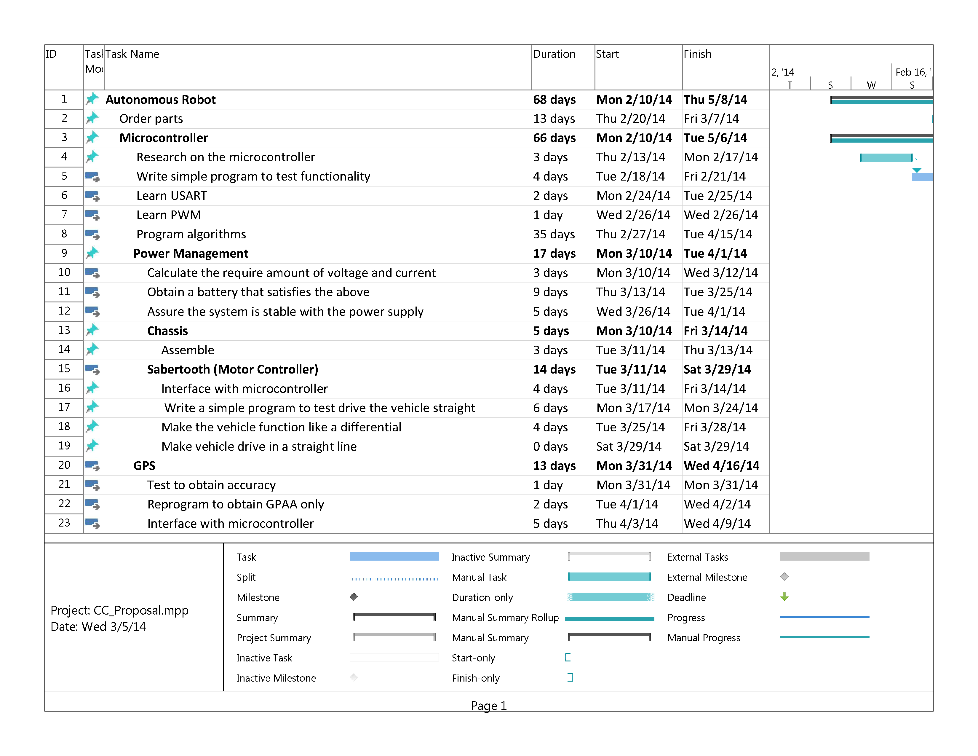
GANTT CHART

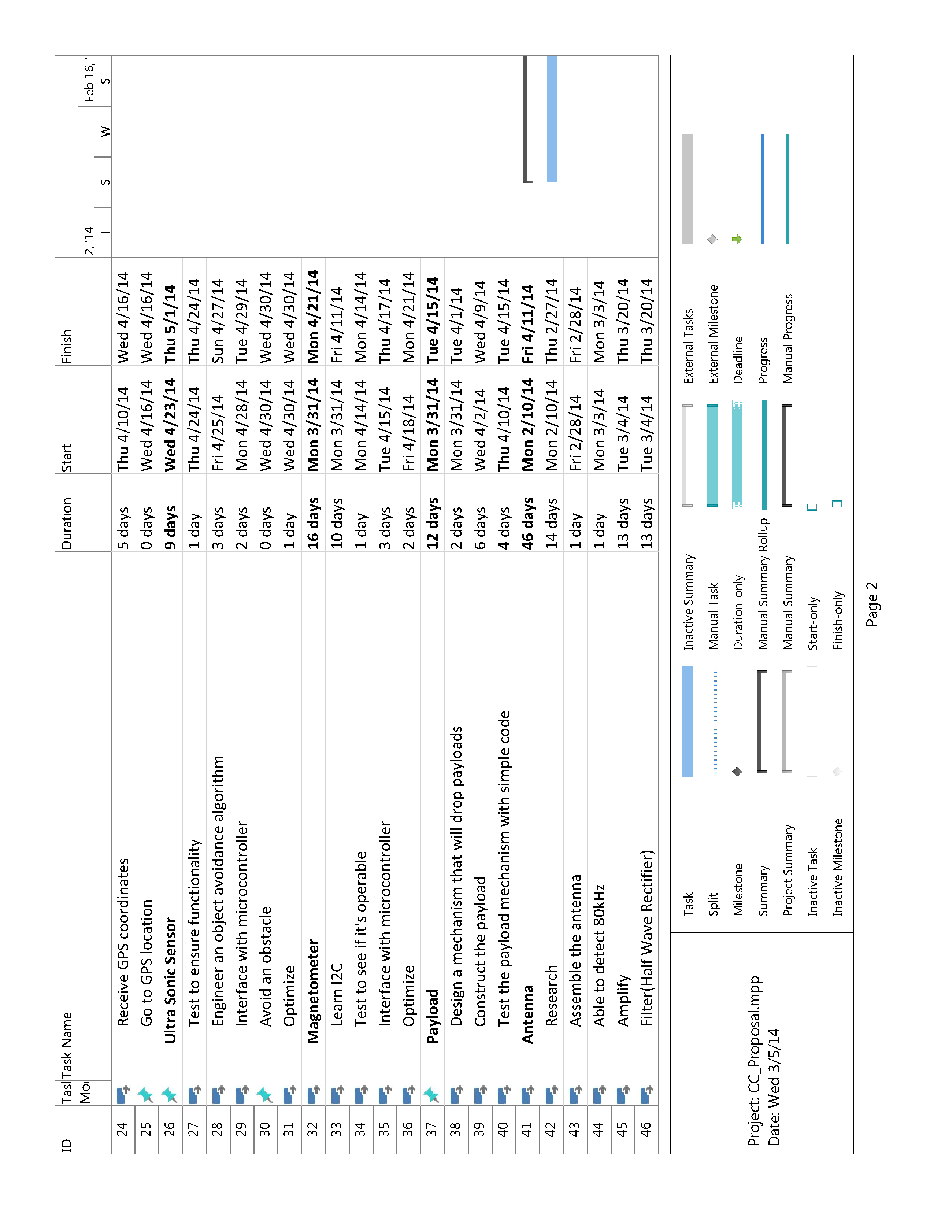

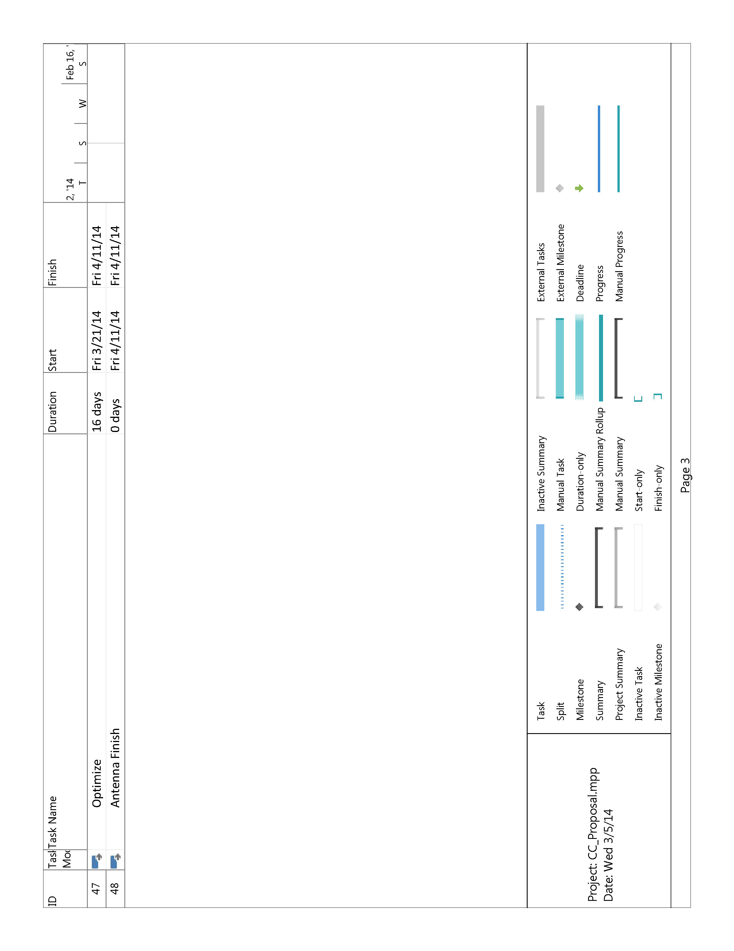
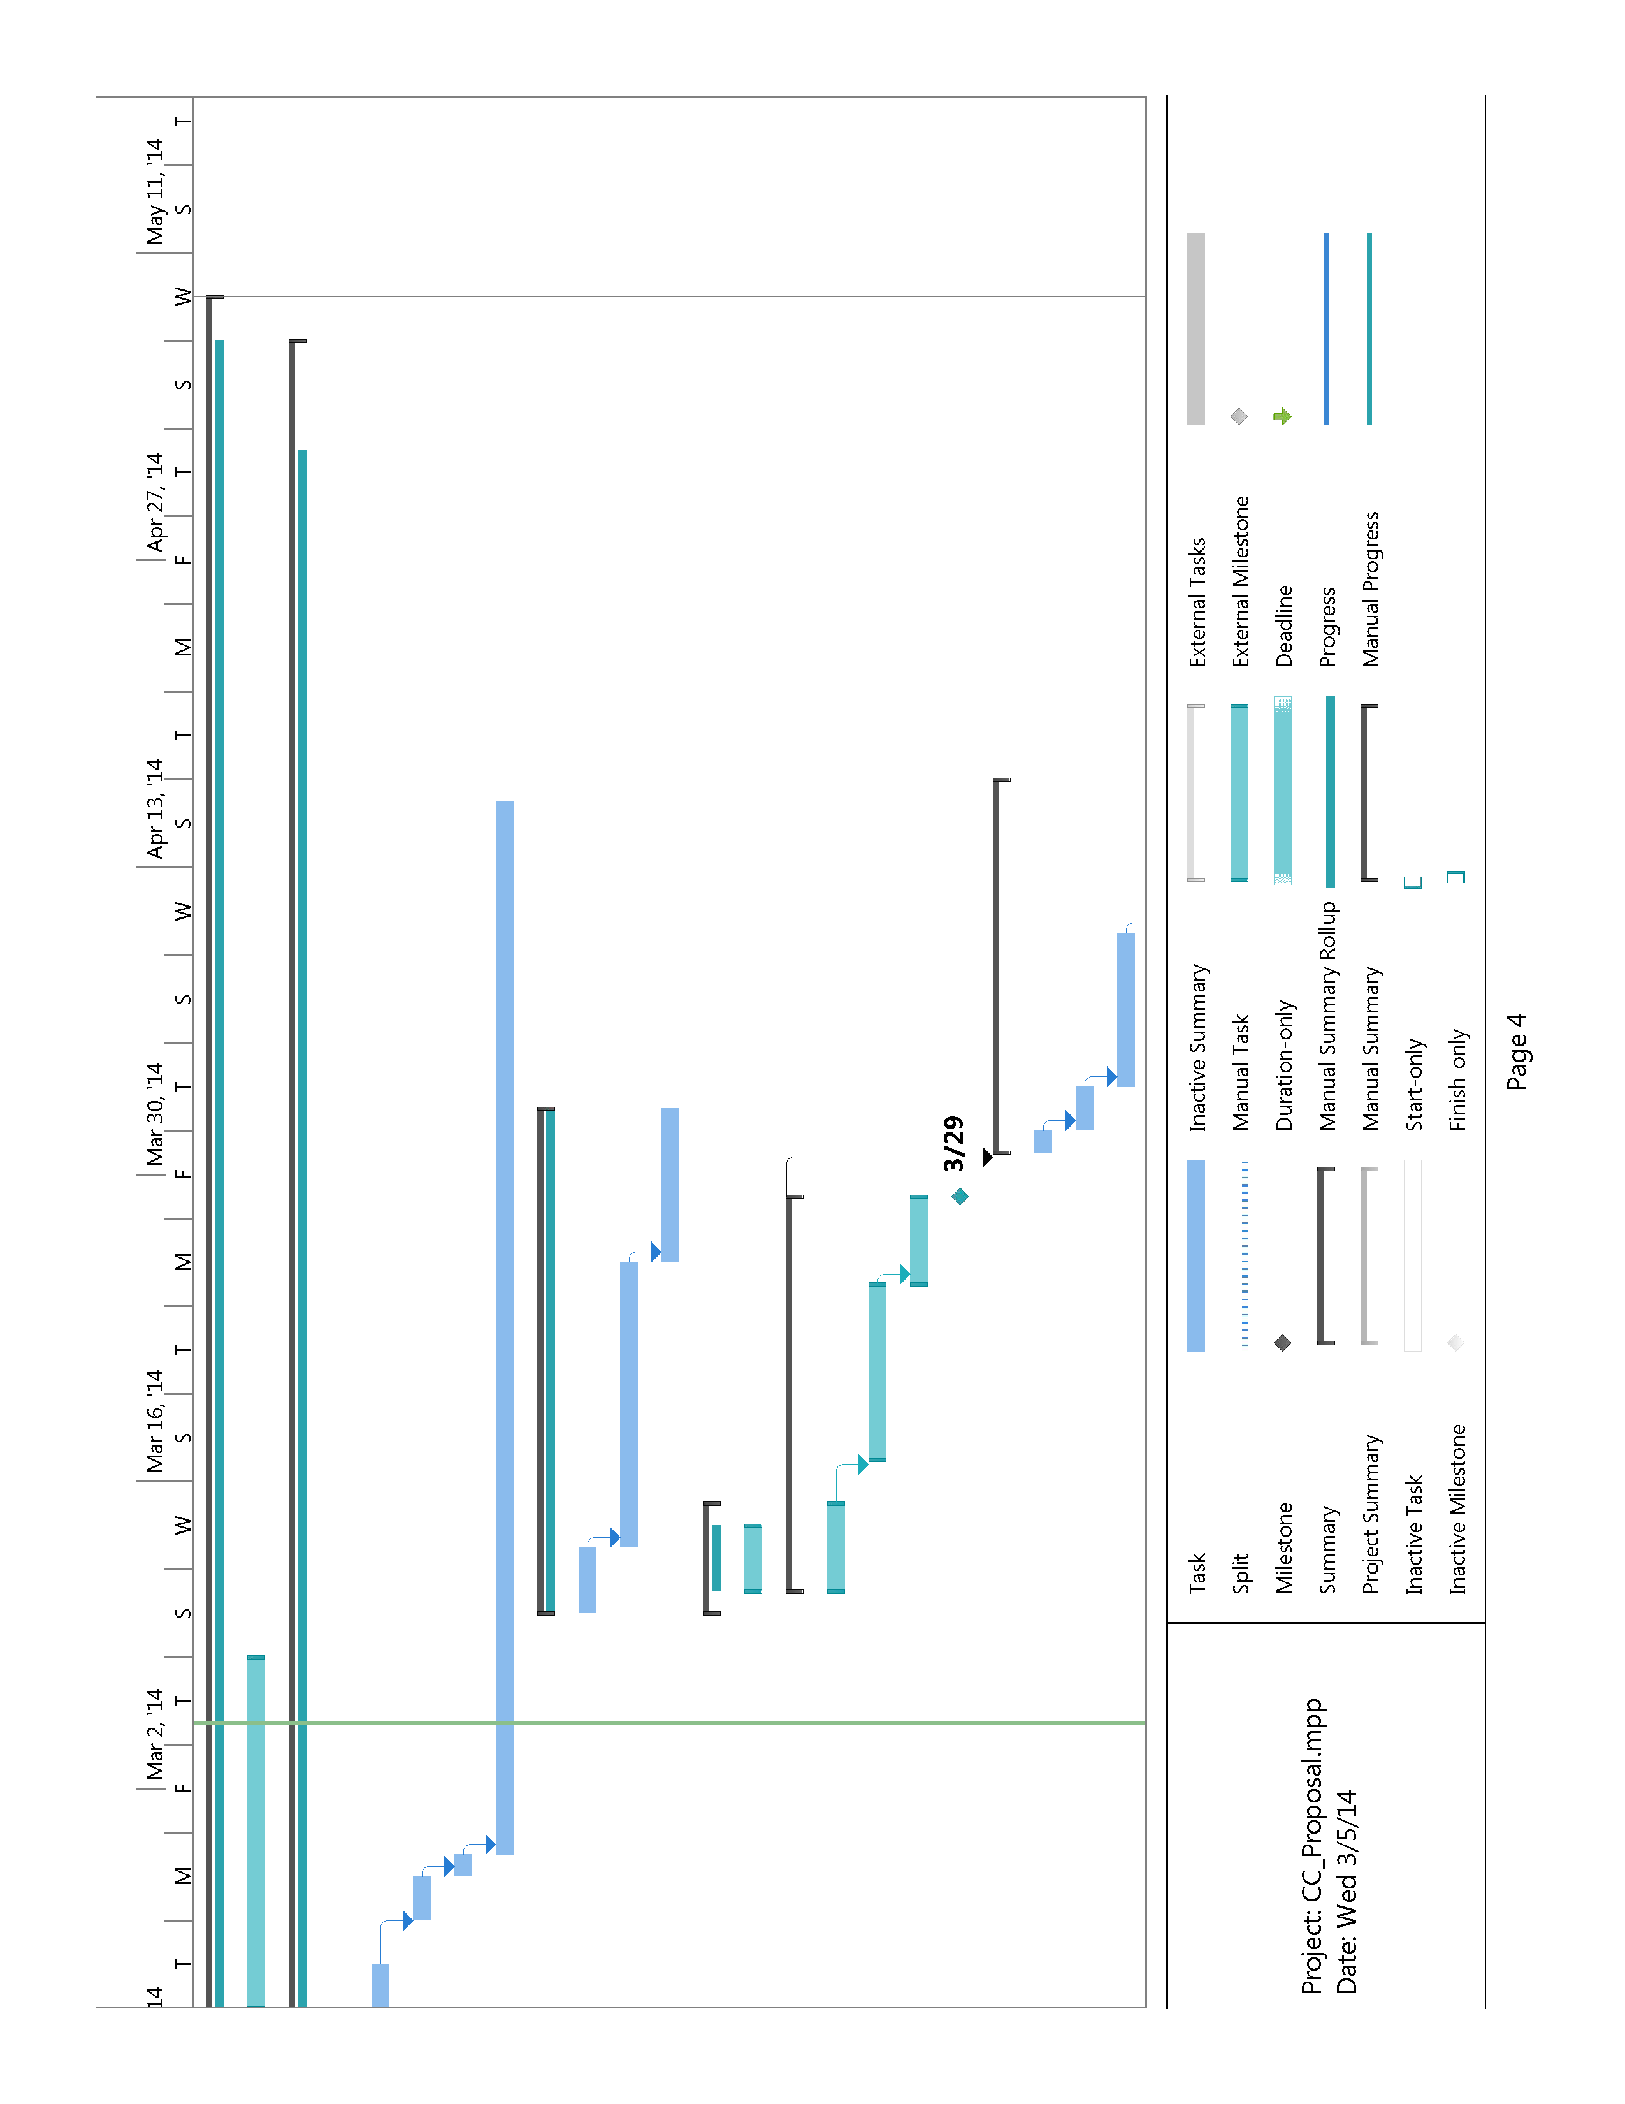
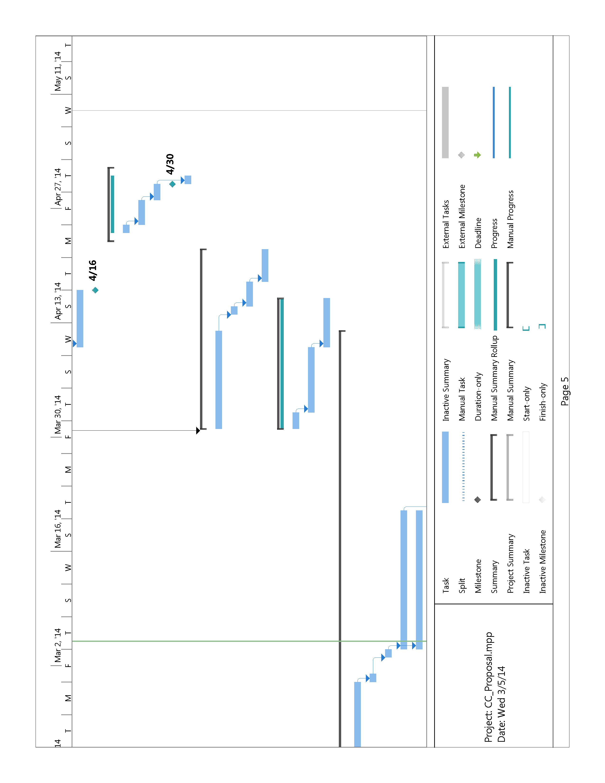
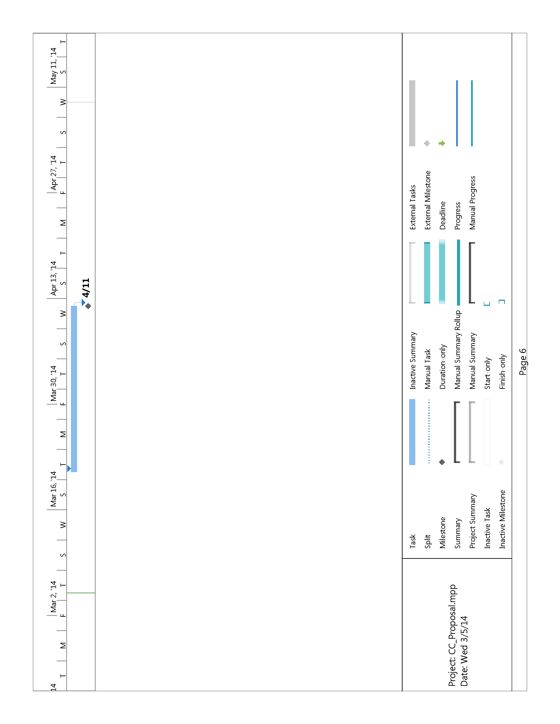
COST ANALYSIS
At Capsule Corp, we believe that every category of this project’s proposed budget holds equal importance because if you remove any thing the design will fail. That is why we place high value on integrating as much as we can from proven companies and focus our limited time on programming and circuit design. As you can see from Figure 1 bellow, we plan to spend the most on the chassis kit which includes the chassis, wheels, and motors. It was very important to us to have a solid foundation to start with. Our Navigation system will comprise of a GPS for location and a 3-axis Magnetometer for direction. For the Power Delivery System we chose the Sabertooth 2x12 Regenerative Motor Controller which has a built in 5V Switching BEC output to power the other on-board electronics.

