

**Robotics Allied Engineering Division**

a

**PROJECT PROPOSAL**

**Micromouse Challenge**

**Sponsored by:**



Department of Electrical

& Computer Engineering

**Submitted to:**

John Kennedy and Dr. R. Lal Tummala

Design Co. Ltd, San Diego, CA

**Design Team:**

Meraz, Fausto

Othman, Rany

Montayre, Patrick

Fernandez, Joshua

Nguyen, Cuong

**Date Submission:**

October 07 2014

Table of Contents

Introduction 2

*Abstract* 2

*Project Description* 2

Design 4

*Block Diagram* 4

*Mock-up Illustration* 6

*Performance Requirement* 8

Testing & Verification 8

*Testing Procedures* 8

*Benchmarks* 10

Project Management 10

*Project Plan* 10

*Milestones* 11

Budget 14

*Cost Analysis* 14

* Promotional Flyer 15

# Introduction

## Abstract

The goal of this project is to design a self-contained, autonomous, electrically powered vehicle called a “MicroMouse,” to negotiate a path to the center of a maze. The micromouse competition is held regularly by chapters of IEEE in various locations. The purpose for forming the Micromouse Robotics Allied Engineering Division, R.A.E.D., is to build a Micromouse that will be competitive in a future competition. This micromouse will contain a combination of sensors, motors, and microprocessors. A group of five technical, electrical and computer engineers capable of such a task has come together in order to design and build a smart micromouse.

## Project Description

The goal for this project is to build an autonomous micromouse, SEN10LS, (Sensor Empowered Navigating 10th scale Labyrinth Solver). The purpose of this micromouse is to navigate through a maze with no external inputs other than the ability to use switches to change algorithms that the micromouse will utilize for different speed modes as well as algorithmic mapping. A competition standard maze is to be 16 units by 16 units square. Each unit equals to 18cm in size, with a maximum space of 16.8cm between walls. A budget of $600 is given by the Department of Electrical and Computer Engineering; with that being said, the total cost of SEN10LS has to be within that limit.

**Objective:**

* The micromouse must be autonomous
* The micromouse should be able to properly map the maze on the first set of runs and execute the shortest path algorithm for the final run to the center of the map
* The micromouse should be able to find the shortest path and run its course in less than ten minutes

**Method:**

The project intendedly is separated into two major groups of software and hardware. The hardware portion is to come up with a design that will put into place two stepper motors, two motor controller boards, three IR sensors, a battery pack, a microcontroller board, and two wheels within a rectangle of 10.5 x 10.5 cm. On the software side, programming in C language will be implemented to control the mouse and at last solve the maze to choose the shortest/quickest path to reach the center. This algorithm/microcontroller will keep track of where the mouse has been inside the maze, control the navigation of the mouse, and optimize the path back to the start.

As mentioned above, our micromouse will consists of the followings:

* Sensors

Sharp brand GP2Y0A51SK0F is an infrared sensor capable of sensing objects from 2cm- 15cm. There will be a total of three (3) sensors mounted to the micromouse: one in front and one on each side.

* Microcontroller

The brain of our micromouse is the PIC/DSPIC Microstick II from Microchip. It will be able to handle the computational algorithms to guide the micromouse from its start to final destination.

* Motor and Motor Drivers.

The motor, we have decided to employ two stepper motors, NEMA-17 42x38mm, and two stepper motor drivers, DRV8825. The DRV8825’s purpose is to control the current and voltage that go into the two motors resulting in a direction and speed.

* Battery

Power will be provided by a Li-Po battery type from Tenergy. The capacity of the battery has yet to be determined; however, since the motor driver requires at least 8.2 V to power the motor itself, we have decided to go with a battery that provides 11.1 V. A voltage regulator is being used in order to bring down the battery voltage to 3.3V for the PIC microcontroller, 5V for the sensors and LVTTL to 5-V TTL buffer drivers. Battery will also be connected directly to the motor driver since its voltage can fluctuate from 8.2-45 V.

# Design

## Block Diagram

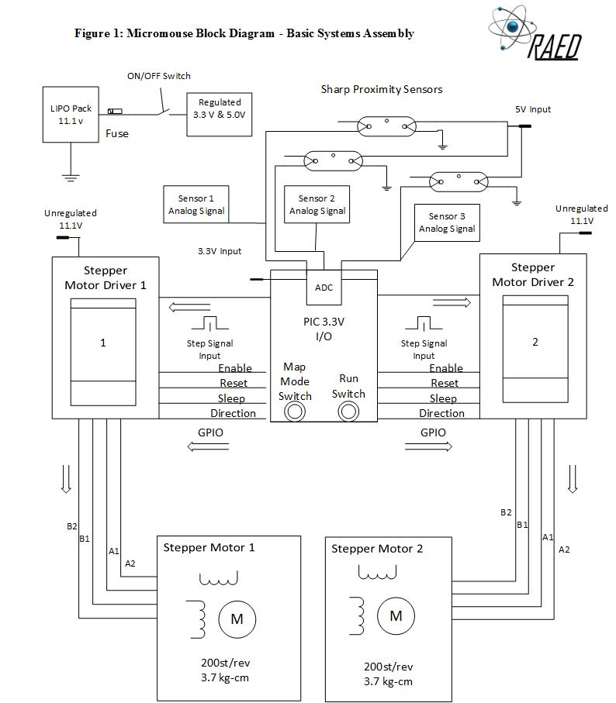

***Figure 1: Micromouse Block Diagram – Basic Systems Assembly***

*As seen in Figure 1, the block diagram consists of various electrical components, each with their own specific role in guiding the micromouse through a maze. We begin with a battery, a main on/off switch, and a voltage regulating circuit to distribute 3.3V and 5V as needed. From there, the complex robotic components begin to take over. Let us start at the PIC microcontroller, which uses its ADC converter to pick up an analog signal from three carefully placed proximity sensors. These proximity sensors measure the distance between our micromouse and the surrounding walls. After the PIC receives this signal, it can convert it into a distance and then determine whether or not to send a specific signal and clock pulse to the motor drivers so that the motors can turn the wheels. If the decision is made to turn the wheels, the signal will include a velocity and direction for each motor. For example, if there is a wall picked up that is closer than a predetermined allowed amount, the PIC will send a signal to the motors drivers to stop the motors or adjust their output in the required fashion. Near the bottom of the diagram you will notice a “Run Switch” and “Map Mode Switch.” The purpose of “Map Mode Switch” is to put the mouse in a maze exploration mode where the mouse circles the maze and calculates the fastest length to the center. The “Run Switch” tells the mouse to solve the maze in the quickest possible fashion.

## Mock-up Illustration

***Figure 2: Mock Up- Top View***

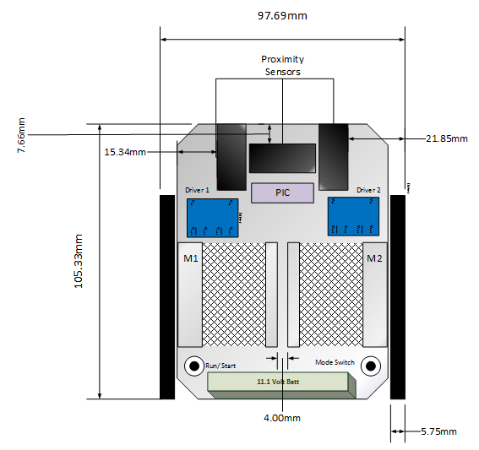

***Figure 3: Mock Up- Front View***

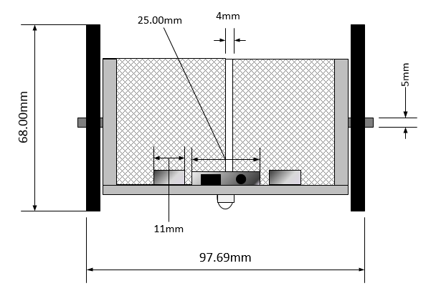

***Figure 4: Mock Up- Side View***

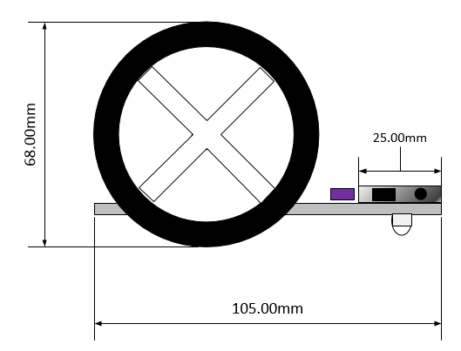

## Performance Requirement

1. Locomotion
2. Must be able to move forward in a straight line
3. Must be able to move a specified distance forward
4. Must be able to make a 90 degree turn, both left and right
5. Sensor
6. Must keep robot in the center of the path
7. Must stop before hitting a wall
8. Must be able to detect openings when a wall is reached
9. Must be able to detect openings to the sides in a straight path
10. Navigation
11. Travel until a wall is reached, then decide which direction to turn using sensors
12. Decelerate if an opening is detected by the sensors before reaching a wall
13. Maze Solving Algorithm
14. Must be able to map out the maze first
15. Algorithm is used to locate the center of the maze
16. Must be able to calculate the shortest route from staring point to the center of the maze
17. Must run that route at the fastest speed

# Testing & Verification

## Testing Procedures

Testing procedure is considered a crucial part in our design. This part will be separated into two different areas in which we call component and integration testing. Component testing basically means that we will test each component individually before assembling them into a final product to ensure that they meet certain specifications stated in the data sheets. On the other hand, integration testing will be done when the micromouse is completely assembled so that we can verify that the mouse meets all the performance requirements so that we can debug any inconsistencies in the performance of SEN10LS.

**Component Testing:**

* Stepper Motors and Drivers: In order to be certain that the stepper motor and the driver we selected function properly together in the maze, they must undergo a series of tests. In order to test the stepper motors, we will be using a function generator at different output frequencies and waveforms to determine the maximum speed and performance it can offer. We can also test the acceleration speed using a sweep signal function. While doing this, we will use a PIC microcontroller to control modes, direction, and sleep pins on the motor driver to see how they affect the overall behavior of the motor. The tests will include monitoring the motor power levels versus temperature to verify and ensure that excess current and heat will never reach the stepper motors resulting in component failure.
* Sharp IR Sensors: In order to test the IR proximity sensors, we will wire them to a 5V dc source and using a sample wall from an authentic micromouse maze, vary the distances between the wall and the sensor. In doing so, we will monitor the output voltages at each of these distances in order to create an accurate, voltage response vs distance, lookup table. This lookup table is very important and will make or break the way the micromouse interprets distances in the maze.
* Battery: To test our battery, we will use the Li-po charger in the SDSU lab to charge and discharge the batteries for numerous cycles as well as install it into a completed micromouse and run it continuously until it shows signs of depletion. In order to make sure the battery is reliable enough for SEN10LS, it must be able to supply full and consistent power for at least ten minutes, the total allowed time in the micromouse competition.

**Integration Testing:**

* As soon as the micromouse is fully constructed, we will begin to test all the systems together. We will commence integration testing which involves a strenuous set of challenges the mouse must complete time and time again in order to ensure success at the competition. It must pass all the performance requirements in order to be considered stable, reliable and ready competition. These tests include avoiding contact with walls without any hesitation and accelerating or decelerating while maintaining stability with no traction loss at all. In terms of embedded systems programing, we will test each function and string of code individually to make sure it does we expect it to do. In other words, if we write a code for the micromouse to turn when it senses a wall, it had better turn. If it fails to satisfy this test, we will not move forward until the code and or hardware is fixed.

## Benchmarks

In order to ensure that our Micromouse is a success, we have created benchmarks based on the comparison of other existing MicroMouse as seen in Table 1.

|  |  |  |  |
| --- | --- | --- | --- |
| Comparing Mice | | | |
| **Specifications** | ***AIRAT2*** | ***Green Giant V4.1 Lite*** | ***SEN10LS*** |
| **Size** | 114x88mm | 93.5x75mm | 97.5x105mm |
| **CPU Board** | JS8051-A2 with LCD | STM32F405RGT6(168Mhz with internal RC) | PIC/DSPIC Microstick II |
| **Wheel** | Aluminum Wheel (51.3 diameter) x 2 | 3D printed mount + mini-z tyres(9.5mm wide) | Plastic Wheel (70mm in diameter) x 2 |
| **Motor** | Stepping motor (H546) x 2 | Fauhalber 1717R(6V)+IE2 512 | Stepper motor NEMA-17 x 2 |
| **Sensor** | IR LED x 6, Photo TR(ST-1KL) x6 | TEFT4300+SFH4545 X 4 | IR LED x 3, Photo TR x 3 |
| **LED** | 1 Power LED, 3 User-LED | 9LEDs + HCMS2903LED Display | 1 Power LED, 3 User-LED |
| **Battery** | Packed NiMH(7.2 Volt 450 mAh) x 2 | 120mah 2s1p | Li-Po Tenergy 11.1V |

***Table 1: Comparing our mouse with other existing mice***

# Project Management

## Project Plan

**Resources:**

* We take advantage of the Senior Design Engineering Lab at SDSU and make it our main location to build and implement this project. The lab has useful equipment such as oscilloscopes, function generators, power supplies, soldering benches, etc. which is very convenient for the team during the building and testing phase.

**Team power: divided in two parts**

* Hardware: Fausto, Rany and Cuong

These individuals are responsible for performing the component testing phase such as sensors, motors and battery testing. They are also tasked to come up with the overall design of the micromouse to determine each component’s position.

* Software: Patrick and Josh

The software team is mainly responsible for getting familiar with the chosen microcontroller so that they can feel comfortable working with it.

## Milestones

In order to achieve the final goal of this project, our group has set up these milestones below:

* Design and build a micromouse that can turn 90 and 180 degrees while keeping track of direction.
* Design and build a micromouse that can avoid walls in a maze.
* Implement an algorithm method so that the micromouse can compute the shortest path to the center.
* Design and build a micromouse that can track how much distance it has traveled in the maze.
* Successfully implement an acceleration profile to the motor driver.
* Design and build a micromouse that can detect the appropriate time to accelerate and decelerate in the maze while keeping stability.

***Figure 5: Gantt chart and Milestones***

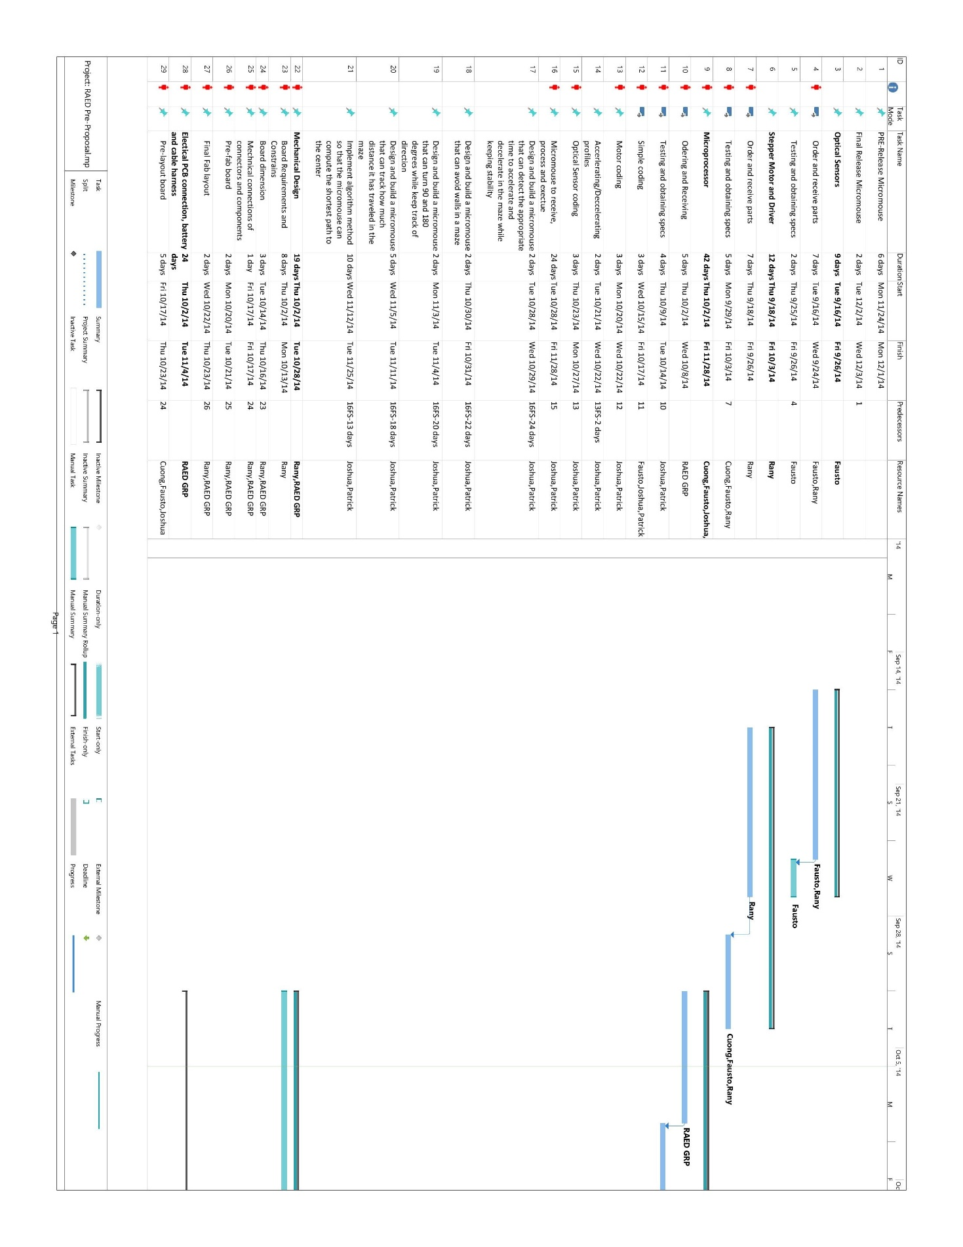

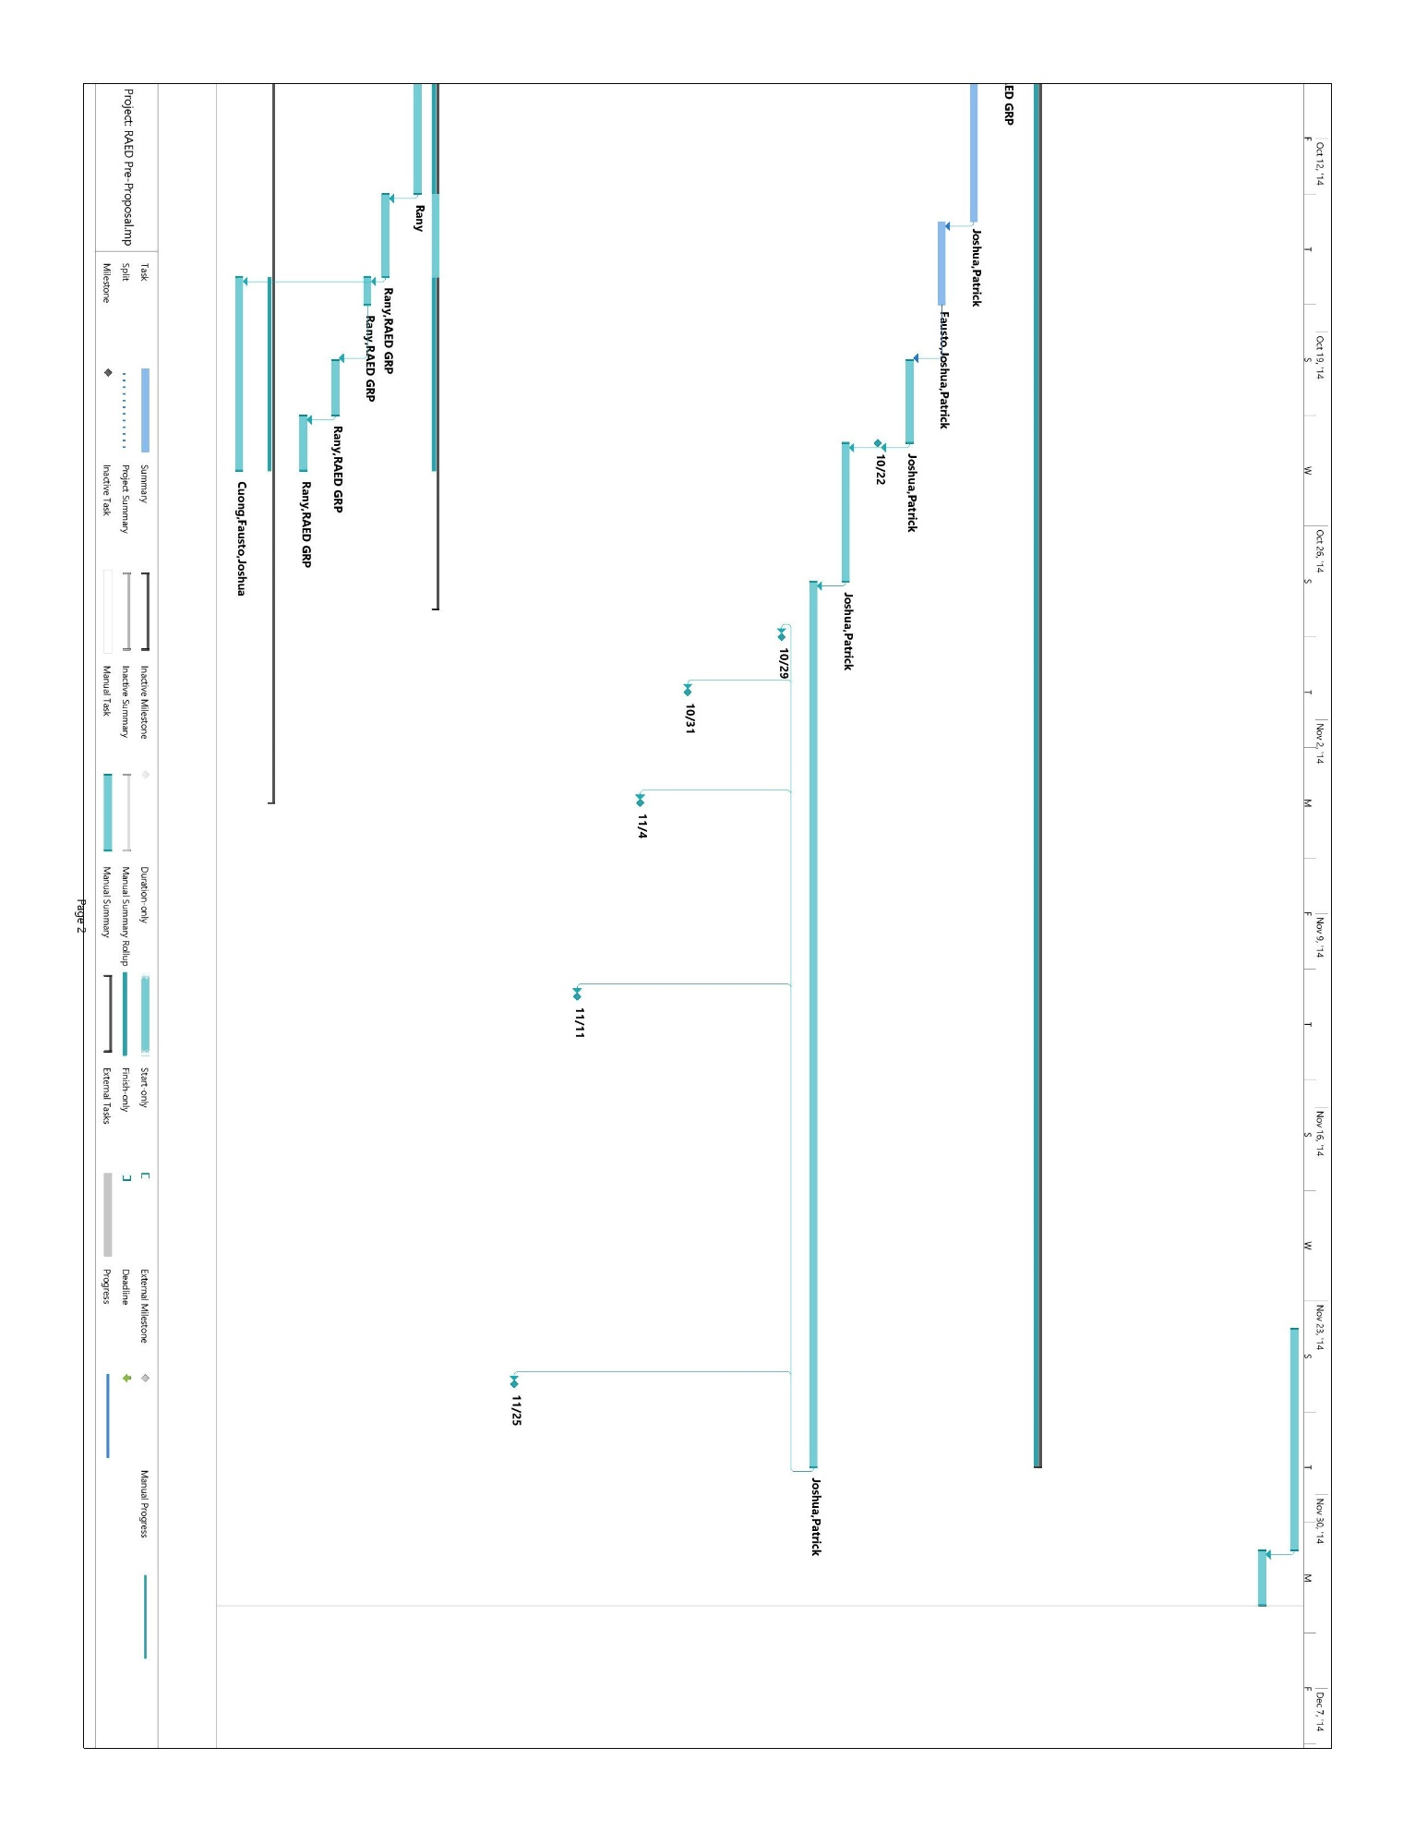

# Budget

## Cost Analysis

***Figure 3: Micromouse Project Budget Distribution***

The pie chart shown in figure 3 provides a rough estimation of how our budget of $600 is being allocated. The locomotion system, around $100, includes two stepper motors, motor drivers, wheels, and various brackets for mounting. We will also order an extra motor and motor driver to have as a spare. We have allotted about $190 to purchase at least two batteries (one to use while the other is charging), which consume the majority the budget. The navigation system, which consists of at least three IR sensors, will receive around $100 so that we could purchase numerous sensors for testing. In terms of microcontroller, we opted to go with the PIC/DSPIC Microstick II, as such, we have distributed $110 specifically for that. We made a group decision to purchase at least two microcontrollers so that two people can work on the programming aspect of the project simultaneously. We have decided to construct a 3-D printed chassis, which will not affect the budget because it can be done by the mechanical department at SDSU. The last $100 is set aside for purchasing miscellaneous materials and hardware.

# * Promotional Flyer

-SEE ATTATCHED PDF FILE FOR FULL RESOLUTION