**Senior Design Project**

**EE/CompE 490**

**C.E.R.E.B.R.O**

**Cognitive Efficiency Recognition Enabled By Recreational Objectives**

**Submitted to: John Kennedy and Lal Tummala**

**Design Co. Ltd, San Diego, CA**

**Sponsored by Yusuf Ozturk, Phd.**

**Loren Wooley**

**Dustin Wright**

**Alex Makedonski**

**Ayron Solomakos**

**Nonoy Suguitan**

**Andrew Fuerst**

**Abstract**

With the recent advancements in the field of electroencephalography (EEG), this has allowed researchers to understand with greater precision what is happening in the human brain. EEG has become the primary means of achieving brain-computer interfacing (BCI), which is a means of translating brain signals into machine commands. This has opened up a door for many practical applications of EEG/BCI, namely in the areas of psychology and entertainment. CEREBO aims to marry these two areas to create a “game of concentration”, in which two players compete to race across a visual medium strictly using their brainwaves; the victor of the game being the player who is most concentrated. Ideally, this project will further the interest in creating cognitive-based entertainment, which very well may lead to the next generation of gaming as well as psychological training tools to improve cognitive function.

**Project Description**

EEG technology has allowed researchers to examine individuals’ brain signals in a variety of cognitive states. This has allowed for the understanding and characterization of a subject’s brain signals, which are divided up into five primary frequency bands. These five primary bands are Alpha (8-15 Hz), Beta (16-31 Hz), Gamma (32 +), Theta (4-7 Hz), and Delta (< 4 Hz). In our project, we are focusing on the state of concentration as a method of controlling a graphical game on a TV screen or computer monitor. Well-established cognitive research has found patterns of brainwaves relating to different cognitive states. It has been found through this research that a higher ratio of energy in the beta frequency range to the alpha frequency range is associated with a concentrated state. Using a small PCB with IC’s capable of collecting and transmitting EEG data wirelessly via Bluetooth 4.0 LE, which will be provided by OzturkLab, CEREBO will process and use this data as the input to the “game of concentration”. The goal and variables of the game are simple; each player will move from start to finish at a rate defined by some fixed rate plus a rate defined by their levels of concentration compared to each other. The rate defined by the EEG input (concentration levels) is the deciding factor in who will win the game. In other words, whoever is concentrating “harder” as determined by the system will be victorious. The project design ` development can be broken up into four generalized steps. These steps also roughly follow the game flow:

1. Design of active sensor to acquire reliable EEG signals from both players’ brains.
2. Conversion of digital signals and live transmission of data over Bluetooth.
3. Simultaneous reception of both EEG data streams on the host application, filtration and processing of raw data.
4. Passing processed data to GUI application. This application will use this data to control the visual interface and game results.

**Design**

A visual representation of the proposed system is displayed below in the form of a block diagram. 

**Mock-Up Illustration**

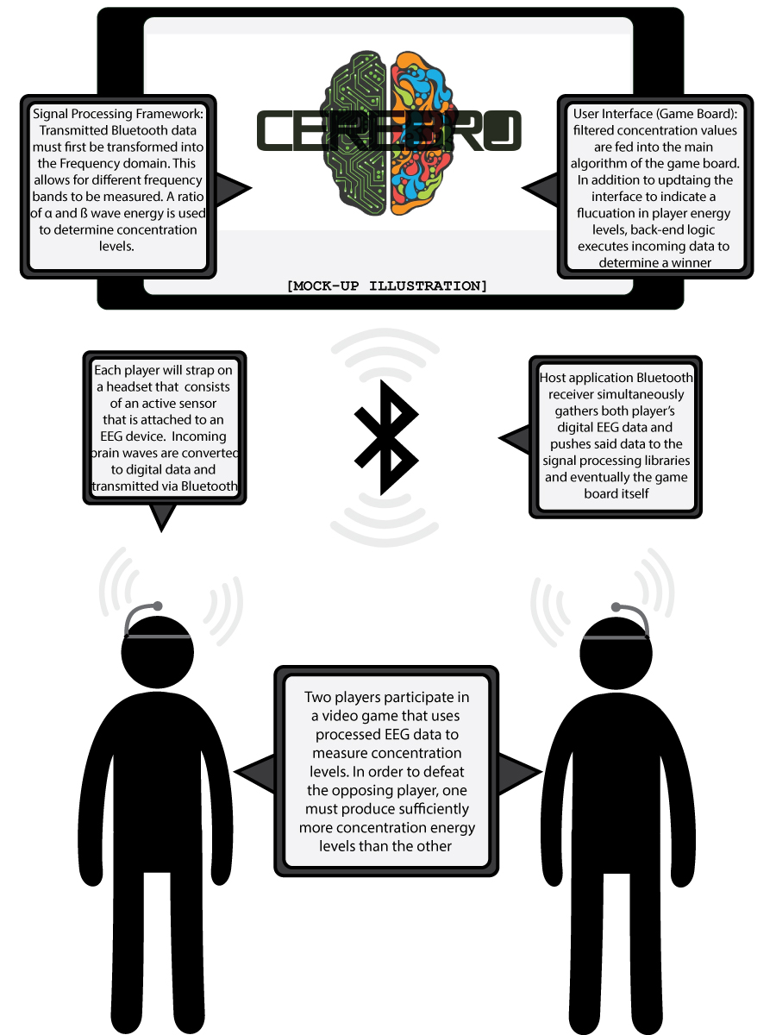

**Performance Requirements**

    Our system should utilize an active electrode as the EEG sensor, which we will develop ourselves. This active electrode will be able to detect brain signals whose frequencies are from 0Hz to 50Hz and whose amplitudes are on the order of several microvolts. The sensor will be input to an EEG module, which has a built in ADC and front-end amplifier to convert the analog brain signal to digital output. This should be packaged as a headband that a person may comfortably wear. The sample rate of the EEG should be at least 256Hz in order to have an acceptable resolution. Once processed through the EEG, the digital signal must be streamed to a host computer using Bluetooth 4.0 LE and subsequently processed using a concentration detection algorithm. We should be able to retrieve data from two different EEGs at the same time. The system should be able to transform the signals to the frequency domain, find the energy of the signals at different frequency bands, and use this information to determine the level of user attention with at least 70% accuracy as is demonstrated in previous studies (see Liu, 2013. “Recognizing the Degree of Human Attention Using EEG Signals from Mobile Sensors”, National Pingtung University of Science & Technology). The level of attention from both users will be used to control a game interface of some sort, which we have decided to be a race-style game. The concrete performance requirements are outlined as follows:

* Active electrodes should accurately sense brain signals between 0 and 50Hz which are on the order of several micro volts and perform identically between both players
* Data should be captured and read from the TI ADS1299 IC (an ADC specifically designed for EEG) with a sample rate of at least 256 samples per second.
* Data should be sent to a host application from two different EEG devices simultaneously
* The EEG we use should be housed in a headset and be streamed using bluetooth low energy (BLE) or a wire.
* Data should be received by the host application accurately and as fast as the sample rate
* Concentration should be detected with at least 70% accuracy.
* A game should be played between two individuals with a maximum of 1 minute of training required.
* The signal processing algorithm should take no longer than the sampling rate to ensure smooth gameplay.
* The winner of the game should be the user who demonstrated a higher level of concentration.
* The game should be played with either a software or a hardware robot.
* The user should have visual feedback of their level of concentration.
* The training method used to determine a user’s baseline concentration level should be tested on enough users to ensure its’ accuracy.

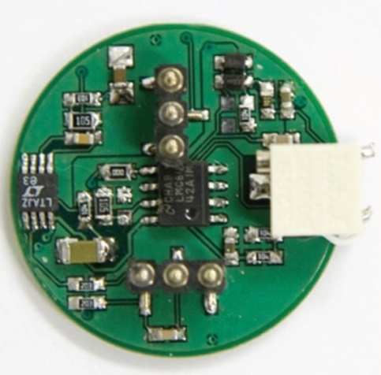**Active Sensor Testing Procedure**

The general requirement of the active sensor is that it must sense distinguishable signals from the brain and deliver a differential output signal to the ADC on the ads1299 board.

**Figure 1:** Active Sensor Example

The specific allowable noise will be determined during testing.

We will benchmark the performance of the active sensor against the professional-grade “GammaCap”, which also utilizes active sensors. We will compare the output signals, both with artificial signals

generated by a function generator and with inputs taken directly from the scalp. The primary interest is that the signal amplitudes generated at the source can be accurately translated into intensity levels in the host application. Therefore, we need to have steady gain across all frequencies in the 1 – 50 Hz band. Another important consideration is that the performance of two sensors (worn by the two competing game contestants) must be identical. To accomplish this, variable resistors are incorporated into the design in order to fine tune the gain and adjust for manufacturing tolerances.

**Bluetooth Testing Procedure**

The Bluetooth technology incorporated on the EEG chip uses the 4.0 specification which permits the communication of LE (Low Energy) systems. The main source of communication within this project relies on the transmission of digital EEG data through the Bluetooth chip. In order to establish a working model of the host application, an additional layer of software must be implemented to pair with the transmitting Bluetooth devices and subsequently push the received data through the signal processing, game algorithm, and GUI software layers. CEREBO plans to implement achieve this using the Nordic nRF51822 bluetooth LE transceiver which is the chip used on the Ozturk EEG board.An already existing C# application was provided that used the Master Emulator libraries associated with the Nordic framework’s ability to recognize the Bluetooth dongle. The application was tested and the dongle was able to recognize nearby Bluetooth devices. To verify the functionality of this technology, the next step would be to establish a connection with a Bluetooth LE device (initially with some Bluetooth emulators for testing, and finally the EEG boards which will use the Nordic chip) and view whether or not data is received from the slave end to the master end. Once that phase has been established, the next step would be to find a way to connect to two devices simultaneously and receive data from both ends whilst being able to differentiate which set of data belongs to which connected device, likely modifying the source code to use multiple threads to accomplish this simultaneous data capture from both devices.

**Signal Processing Test Procedure**

    The method we will use to process the raw EEG data is to extract features from the EEG signal and use them as input to a support vector machine (SVM). A support vector machine is a classifier which works by finding a hyperplane that separates two sets of labelled data with the widest margin. A most probable class can then be predicted for new input vectors using a decision function calculated by the SVM. The following procedures will be used to test this scheme.

With this scheme, we will train the system by having the user relax for 30 seconds through something like a short guided meditation program, then concentrating for 30 seconds by attempting to solve a maze on the screen. During each of these tests, we will extract five features from the EEG signal: the energy in the alpha, beta, theta, and delta bands as well as the ratio of the energy of beta to alpha waves. Features will be extracted in 0.5-1 second intervals and added to a pool of training data. At the end of the minute of training, we will perform *k*-fold cross-validation to determine the SVM parameters that will give us the highest prediction accuracy. Cross-validation works by separating the training data into *k* partitions, with one partition being “test” data and the rest being training data. The SVM is trained using the training data and predictions are made for both the training and testing data. This occurs *k* times so that each partition is used as testing data. The predicted classes are then compared to the expected classes at each iteration to determine the percentage of correctly predicted data. The average of this percentage over all *k* iterations gives us a metric of the accuracy of the support vector machine.

To further test this method, we will have multiple users go through the training phase, and average the cross-validation accuracy for these users. Then, we will have the users play the game developed in the host application where we will collect more data, creating a testing set for these users. We will input this testing data to the support vector machine using the model created during the training phase, and see what percentage of inputs are accurately predicted based on if the user said they were concentrating or relaxing. If we achieve greater than 70% accuracy for both cross-validation and testing, we will have met our milestone.

**Benchmarks**

Once the first version of the project is complete, it is necessary to test whether or not it is performing as expected. This is where the problem of subjectivity arises. Since concentration is not able be explicitly measured in the same way between individuals due to different brain structures, the support vector machine scheme described previously is ideal in determining the validity of our results because it sets a baseline for each player for relaxed vs. concentrated states during the training phase. This is the method used by currently existing systems, in which a subject’s levels of attention or concentration are measured not only by observing their brain signals, but also by relying on the subjects’ perceived levels of attention. It is impossible to determine the accuracy of our results without the users’ honest feedback on whether or not they felt concentrated during the experiments. In order to determine if the results trend in the expected direction, the first trial of the game (after the training phase) would have Player 1 attempting to concentrate with whatever method they find best, while Player 2 would intentionally try to be unfocused (perhaps being distracted by someone else, receiving a variety of visual and auditory distractions, etc.). This should cause Player 1 to win by a significant amount. If this is the case, more experiments could be performed to determine the accuracy of our concentration detection method. After the testing of the Bluetooth data transmission, signal processing, and game controls described previously is complete, these benchmark tests should determine whether the design is behaving according to expectations.

**Project Plan**

Resource Requirements

* Components to create active sensors and headsets
* Various software packages (PCB Design, signal processing, schematic tools, bluetooth libraries, SolidWorks)
* EEG boards provided by Dr. Ozturk
* Bluetooth dongles
* Development boards and bluetooth emulators for testing against
* Software development kits (i.e. Windows Forms)

**Plan Implementation**

    We will use the components and PCB design software to develop the active sensor. This should be finished around October 16th. The signal processing tools will be used to develop a concentration detection algorithm which will also be finished by October 16th. The development boards are to be used for obtaining EEG data and getting this data to a host application. We should have data by October 23rd. In addition, we should be able to stream data from two devices at that point. A game should be fully developed on the host application by the 23rd as well. The data acquisition and concentration detection will then be integrated into the main host application by the 28th, at which time we will have one or more users successfully control the game we developed using only their concentration. By November 4th we will have finished the host application, including data acquisition, concentration detection and gameplay. At this point, we will move into a system integration phase at which time we will incorporate our developed sensor and headset into the system. We plan to have everything fully integrated by November 11th. After this, we will begin testing where all bugs will be fixed and all hardware debugged. Testing will last until November 25th at which time the system should be fully ready for design day. On December 5th we will participate in design day where we will be able to have users come and play with the system for themselves. See Gannt chart attached for a detailed timeline of milestones.

**Budget**

|  |  |  |
| --- | --- | --- |
| **Item** | **Purpose** | **Cost** |
| 1. Insignia Bluetooth Dongles (2) | Capture BLE signal from Ozturk board | 2*$20 = $40 |
| 2. Electrical components | To build active sensors | $200.00 |
| 3. TI ADS1299 Development Kit | Testing of data capturing/transmission (backup plan) | $199.00 |
| 4. Headset hardware | To build 2 functioning headsets | $100.00 |
| 5. Bluetooth emulators | Bluetooth prototyping prior to arrival of Ozturk board $75.00 | |
|  |  | **Total = $614.00** |

**Promotional Flyer**

